Members of the Council are hereby summoned to attend the
STEEPLE BUMPSTEAD PARISH COUNCIL Meeting @ The Moot Hall
ON Thursday 14th March 2024 at 7.30pm for the purpose of transacting the following business.
Members of the press and public are welcome to attend.
9th March 2024
Julia Howard, Clerk to Steeple Bumpstead Parish Council
AGENDA
24/029 Welcome and to receive apologies for absence Chairman
24/030 Declarations of Interest Information
To declare any Disclosable Pecuniary, Pecuniary or non-Pecuniary Interest relating to items on the agenda
24/031 To approve the minutes (previously circulated) Decision
of the Parish Council meeting held on 8th February
24/032 Question Time Information
Public Participation Session with respect to items on the agenda and other matters of mutual interest. Please note: The maximum time allowed for this item is 15 minutes but may be extended at the discretion of the Chairman
24/033 Invitation to Cllr Peter Schwier, Essex County Council and Cllr Diana Garrod, BDC Information
to address the meeting on matters of mutual interest.
24/032 Village Showcase / New Annual Village meeting -update to note

24/033 Planning Applications
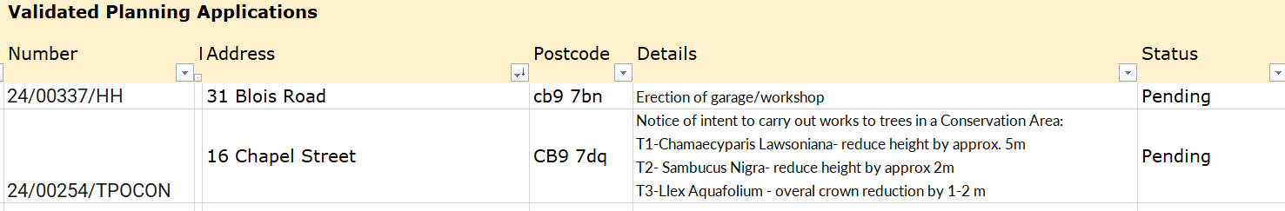
Decisions:
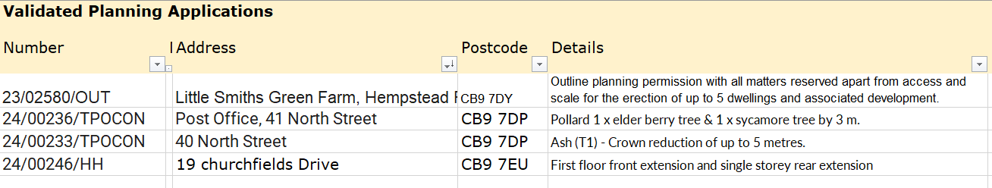
*decisions not recorded on this agenda due to a BDC server error.
24/034 Neighbourhood development plan – standing item for updates Information
24/035 Financial Matters To note and Decision Item 1. To note receipts and approve upcoming payments
Item 2. Clerk’s report
24/036 Parish Online – Cllr Swaby will do a short demonstration on screen.
24/037 Open Spaces
Item 1. - Play area Safer Surface update – surface is booked in
Item 2. - Open Spaces, Trees, Street Lights and Assets – mapping on Parish Online required
Item 3. – Flood Initiatives Group (FIG) – update
Item 4. – Open Spaces training – Cllr Mackenzie to provide a summary of his recent course

24/038 Maltings House Lane / Road – to note, communication with the Road Names team
24/039 Churchyard wall – update on status / progress.
24/040 Yellow Book Deadline – deadline is the 15th.
24/041 Information Sharing
24/042 Meeting Close & Date of Next meeting (village showcase 21/04/24, Annual PC Meeting 16/05/24)

