**STEEPLE BUMPSTEAD PARISH COUNCIL Annual Council Meeting @ The Moot Hall**

**ON Thursday 12th June 2025 at 7.30pm**

Chair: Cllr Kerry Barnes

In attendance: Cllr Westrope, Cllr Rust, Cllr Borges, Cllr Hill, Cllr Mackenzie, Cllr Lacey, Cllr Garrod.

Clerk: Mrs Julia Howard

Members of the public:Two

**Minutes**

**25/076 Welcome and to receive apologies for absence -** Apologies received from Cllr Hexter, Cllr Swaby & Cllr Schwier.

**25/077 Declarations of Interest Information**

To declare any Disclosable Pecuniary or non-Pecuniary Interest relating to items on the agenda - none

**25/078 To approve the minutes** (previously circulated) of the Parish Council meeting held on 15th May 2025.

RESOLVED Proposed by Cllr Rust, seconded by Cllr Mackenzie all agreed by show of hands

**25/079 Question Time** **Information**

Public Participation Session with respect to items on the agenda and other matters of mutual interest.

First member of the public advised they are observing but did mention the number of potholes which are becoming an issue again.

The second member of the public raised the issue of a quiet lane application at Maltings Lane, this was put on hold due to the works by Anglian Water. Cllr Lacey will take this forward along with looking into possible speed reductions on Bower Hall drive, by the school and Church street. Clerk to send information to Cllr Lacey.

Planning application for Maltings Farm was also discussed, the PC has put in an objection and is aware that there were some errors on the application, in particular the address had the wrong road named. Cllr Garrod was asked to request that the planning department and Highways look again with fresh eyes in consideration of the wrong road address. Cllr Garrod did this prior to the minutes being written and copied the clerk into the email request.

**25/080 Invitation to Cllr Peter Schwier, Essex County Council and Cllr Diana Garrod, Braintree District**

**Council** to address the meeting on matters of mutual interest.

Cllr Garrod gave her report (a copy is on the PC’s website), starting with road closures. The household waste, recycling and food collection service will be changing from June 2026. There is a local plan sub committee meeting tonight re: Birdbrook and Baythorne End.

The PC’s planning group could put together a statement to be submitted in response to the ‘call for site’ next stages. Cllr Borges to draft a statement to submit.

**25/081 Footpath 29 – Parsonage Farm** – Extinguishment, pre-application enquiry. The property owners would like to have the PROW extinguished, they have concerns over security and note that there are alternative routes nearby. Cllr Rust who is our lead for footpaths and PROWs has liaised with ECC highways regarding this and the process. The Parish Council has no power to make a decision on this; however, it would be sensible to inform the public and enquire to see whether it is used by many people.

The PC has vehicular rights of access via this PROW, to allow access to the Camping Close and we would need to understand whether that would be affected. The PC will raise a notice in the next yellow book.

There is a sign for public footpath which is partially hidden by hedge/bush growth.

**25/082 Financial Matters To note and Decision**

**Item 1.** To note receipts and approve upcoming payments. Clerk will also open up a Unity Bank account and charge card.

RESOLVED All agreed by show of hands

**Item 2.** Insurance update – we have not yet received further quotes, deadline 26/6

Clerk to liaise with the Finance Working group when quotes received to proceed with preferred Insurance offer.

**Item 3.** Audit update– the external audit has been submitted, notice of public rights dates on noticeboard.

**Item 4.** Handyman (2) applications. 3 enquiries and to date 1 application received. Clerk will liaise with Personnel working group to arrange an interview at the Camping close before next PC meeting.

**Item 5.** IT Update (.gov emails, MS365 and website)to meet updated SAPP requirements for audit 2025-26. The group of Councillors moving this forward will meet on 18th June.

**25/083 Planning**

**Applications**

**No new applications received at time of agenda issue.**

Late addition 8 Chapel Street TPO – no comment

**Decisions**



**Other – None at present.**

**25/084 Neighbourhood development plan,** to receive an update **Information**

This has now been adopted by Braintree District Council, and will be on the PC’s website next week.

**25/085 Request for 1100litre bin placement** to be used for purple bags, the District Council has asked to **RESOLVED** place a large bin for the purple bags by the bottle banks, the PC would like it to be lockable with a combination padlock. The clerk will respond to the District Council. **Decision**

**25/086 Churchyard Wall working group update Decision**

The working group has been getting updated pricing and will apply for grants and do the work in phases. The PC has put aside a sum of money to use for match funding where needed. A laser scan survey has been done. Details of costing will come to a future PC meeting for a decision when needed.

**25/087 Camping Close ROSPA inspection Decision**

Cllr Mackenzie has prioritised the actions on the ROSPA report, and the clerk will circulate this before the working group meeting on 3rd July.

It includes the need for more woodchip, metal caps on the remaining wooden legs of the climbing frame and removal / replacement of the trim trail.

**O T H E R I T E M S F O R D I S C U S S I O N**

**25/088 Events – VJ day, 15th August –** The PC will consider whether to arrange something, however there was little interest in VE day plans, and the local pubs had a great turnout for things they had arranged.

**25/089 Camping close regeneration** – Started on 2nd June – progress report. Slight delay due to the weather but the project has started. Between the date of the PC meeting and the minutes being written, the PC was notified of a further delay. Therefore, the initial date for an official opening was moved to Sunday 13th July. The clerk will purchase some games accessories (tennis balls and cricket bats, outdoor table tennis bats and balls and a ribbon to be cut). Cllr Garrod and Cllr Schwier have been invited to help open it as it was mostly funded by s106 funds and a CIF grant.

The plan is to have a picnic on the green and invite the ice cream van and/or have a BBQ and some fun games to try to raise funds for picnic tables. Clerk to do a save the date poster. The Events group will liaise in pulling this together. Volunteer help always welcome, please contact the clerk.

**25/090 Update on outstanding actions from previous meeting/s**

1.Noticeboard removal / installation, delayed, Cllr Swaby will do this. In the meantime, the doors and drawing pins to be removed from old notice board for safety reasons. 2. Storage of the winter salt – Cllr Rust is arranging this in the coming weeks 3. Gate at churchyard – waiting for a tree to be cut back first, requires a faculty for this 4. Rope net replacement, will be taken further at the WG meeting on 3rd July, as repairs are required to the legs also. 5. Missing swing and incorrect swing heights – WG meeting on 3rd July. 6. Process for payments to the library – this has been agreed with the library representatives 7. Yellow Book Rota – the clerk has circulated a rota for the next 3 years.

**25/091 Information Sharing –** Cllr Rust – the village hall is having a gardening club launch meeting on 22nd June. Cllr Borges – none, Cllr Hill – none, Cllr Mackenzie – asked for an update on the overgrown hedge on Water lane by Poppyfields, the Chair read an email response following the request to Cllr Schwier to follow up on the request to have it trimmed. ECC consider there is not an issue and have asked for photographic evidence. *Additional photos were provided on Monday 18th June and the County Councillor has taken this further with Highways.*  Cllr Westrope – none, Cllr Lacey – none.

**25/092 Meeting Close & Date of Next meeting –** 10th July. Closed 21.21

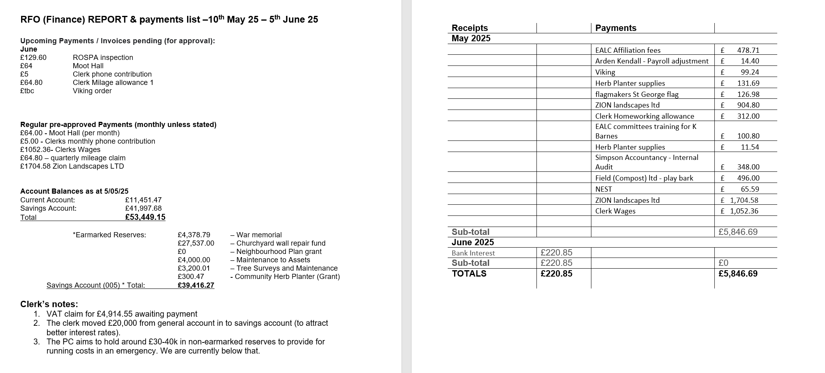

**Signed by Chairman ……………………**

**Date …………………………………………….**