Members of the Council are hereby summoned to attend the
STEEPLE BUMPSTEAD PARISH COUNCIL Meeting @ The Moot Hall
ON Thursday 8th January 2026 at 7.30pm for the purpose of transacting the following business.

Members of the press and public are welcome to attend.
2nd January 2026
Julia Howard, Clerk to Steeple Bumpstead Parish Council
A G E N D A

26/001 Welcome and to receive apologies for absence Chairman
26/002 Declarations of Interest Information
To declare any Disclosable Pecuniary or non-Pecuniary Interest relating to items on the agenda
26/003 To approve the minutes (previously circulated) Decision
of the Parish Council meeting held on 11th December 2025.
26/004 Question Time Information
Public Participation Session with respect to items on the agenda and other matters of mutual interest. Please note: The maximum time allowed for this item is 15 minutes but may be extended at the discretion of the Chairman
26/005 Invitation to Cllr Peter Schwier, Essex County Council and Information
Cllr Diana Garrod, Braintree District Council to address the meeting on matters of mutual interest.
26/006 Financial Matters To note and Decision
Item 1. To note receipts and approve upcoming payments
Item 2. Precept request
Item 3. Cllr training (update)
Item 4. Recruitment update / progress
Item 5. IT Update (.gov emails, MS365 and website) to meet updated SAPP requirements for audit.

26/007 Planning
Applications –
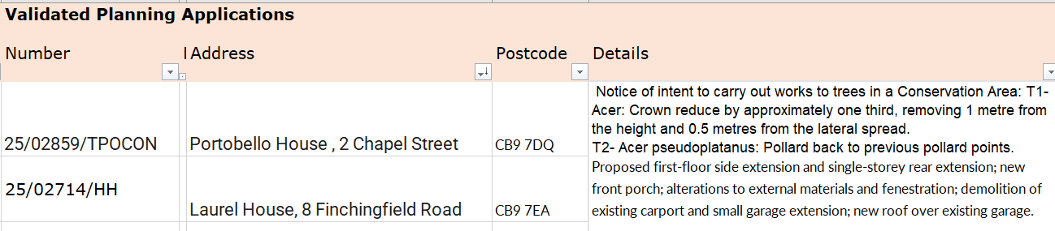

Decisions
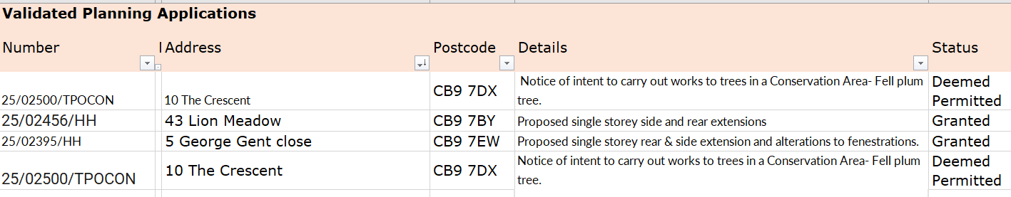

26/008 Actions from Working Groups meeting Decision
O T H E R I T E M S F O R D I S C U S S I O N `
26/009 Events – Village showcase
26/010 Update on outstanding actions from previous meeting/s
26/011 Information Sharing
26/012 Meeting Close & Date of Next meeting – 12th February.

