**Members of the Council are hereby summoned to attend the**

**STEEPLE BUMPSTEAD PARISH COUNCIL Annual Council Meeting @ The Moot Hall**

**ON Thursday 15th May 2025 at 7.30pm for the purpose of transacting the following business.**

**Members of the press and public are welcome to attend.**

9th May 2025

Julia Howard, Clerk to Steeple Bumpstead Parish Council

**A G E N D A**

**25/057 Election of Chairman Decision**

Declaration of acceptance of office to be signed by new chairman

**25/058 Election of Vice Chair Decision**

Declaration of acceptance of office to be signed by new vice chair

Following a successful appointment to both positions the meeting will follow as per the agenda below

**25/056 Welcome and to receive apologies for absence Chairman**

**25/057 Declarations of Interest Information**

To declare any Disclosable Pecuniary, Pecuniary or non-Pecuniary Interest relating to items on the agenda

**25/058 To approve the minutes** (previously circulated) **Decision**

of the Parish Council meeting held on 13th March 2025.

**25/059 Question Time** **Information**

Public Participation Session with respect to items on the agenda and other matters of mutual interest. Please note: The maximum time allowed for this item is 15 minutes but may be extended at the discretion of the Chairman

**25/060 Invitation to Cllr Peter Schwier, Essex County Council and Information**

**Cllr Diana Garrod, Braintree District Council** to address the meeting on matters of mutual interest.

**25/061 To receive reports from; Information**

**The Village Hall Committee**

**The Moot Hall Committee**

**25/062 Essential Housekeeping for the Annual meeting Decision**

**Item 1**. Adoption of Standing Orders, Financial Policy and Reserves Policy

**Item 2.** Review and agreement of Delegation Arrangements and approve the scheme of delegation to the clerk

**Item 3**. Review of working group responsibilities and membership to other bodies

**Item 4**. General Power of Competence – confirmation of adoption for a third year **Decision**

**25/063 Council Meetings Decision**

1. To agree dates and times for ordinary meetings for the next year (2025/26)
2. To agree the location for ordinary meetings
3. To agree a day / time for any other scheduled meetings

**25/064 Financial Matters To note and Decision**

**Item 1.** To note receipts and approve upcoming payments

**Item 2.** To approve the Year end accounts and Earmarked reserves for 2024/25

**Item 3.** To approve the Fixed Asset register as of 31/3/25

**Item 4.** To receive the report for the Internal Auditor for 2024/25 & agree any action

**Item 5.** To complete and approve the Annual Governance Statement for 2024/25

**Item 6.** To approve the Accounting Statements for 2024/25

**Item 7.** To note the dates for the Publication of Notice of Public Rights

**Item 8.** To approve processing of regular payments list

**Item 9.** To confirm Insurance cover for the coming year – due for renewal in June

**Item 10.** To review the Council’s expenditure incurred under s137 (LGA 1972)

**Item 11.** To confirm the Internal Auditor for 2025/26

**Item 12.** Review of earmarked fund accounts

**25/065 Planning**

**Applications**

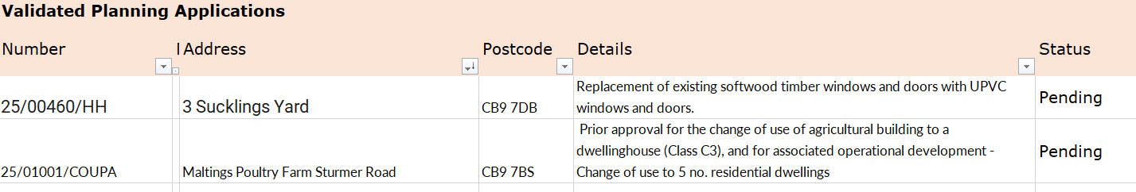

**Decisions**

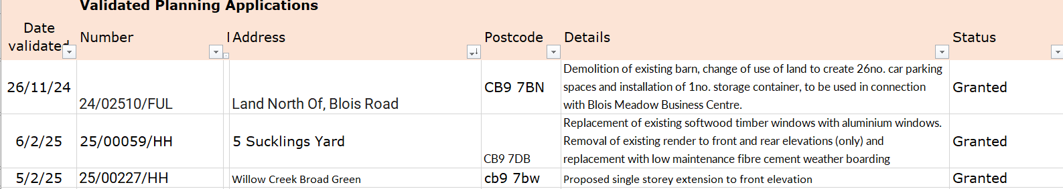

**Other – None at present.**

**25/066 Neighbourhood development plan,** to receive an update **Information**

**25/067 Churchyard Wall Decision**

**O T H E R I T E M S F O R D I S C U S S I O N**

**25/068 Yellow Book Deadline –** 16th May

**25/069 Herb and Sensory Planter** – (this is now part of Bumpstead in*Bloom)* Steeple Bumpstead Cubs group are going to be planting the vegetable box for the year

**25/070 Camping close regeneration** – to commence w/c 2nd June.

**25/071 Village Showcase and Annual Village Meeting** – with thanks to the Events group

**25/072 Working groups meeting** – a one-off meeting to plan the forward direction for this year and beyond

**25/073 Update on outstanding actions from previous meeting/s**

**25/074 Information Sharing**

**25/075 Meeting Close & Date of Next meeting**