**STEEPLE BUMPSTEAD PARISH COUNCIL Annual Council Meeting**

**The Moot Hall ON Thursday 16th May 2024 at 7.30pm**

Chairman: Cllr Kerry Barnes

In attendance: Cllr Mackenzie, Cllr Westrope, Cllr Hill, Cllr Swaby, Cllr Borges, Cllr Hexter, Cllr Rust.

Also present: Cllr Peter Schwier, Cllr Diana Garrod

Clerk: Mrs Julia Howard

Members of the public - four

**MINUTES**

**24/043 Election of Chairman Decision**

Declaration of acceptance of office to be signed by new chairman

Cllr Kerry Barnes for chairman, proposed by Cllr Swaby

**24/044 Election of Vice Chair Decision**

Declaration of acceptance of office to be signed by new vice chair

Chairman Cllr Barnes proposed Cllr Hill, seconded by Cllr Mackenzie, all agreed.

Following a successful appointment to both positions the meeting will follow as per the agenda below

**24/045 Welcome and to receive apologies for absence** -none **Chairman**

**24/046 Declarations of Interest Information**

To declare any Disclosable Pecuniary, Pecuniary or non-Pecuniary Interest relating to items on the agenda. Cllr Barnes ref planning (1 Blois road) – noted.

**24/047 To approve the minutes** (previously circulated) of the Parish Council meeting held on 14th March 2024. Proposed by Cllr Mackenzie to accept as a true record, seconded by Cllr Westrope, all in agreement.

**24/048 Question Time** **Information**

MOP in attendance to raise concerns over road closed signs. The PC has raised concerns to Anglian Water and asked for additional signage. Concerns over the difficulty of making claims for pothole damage and reports of drain covers needing repair.

**24/049 Invitation to Cllr Peter Schwier, Essex County Council and Information**

**Cllr Diana Garrod, Braintree District Council** to address the meeting on matters of mutual interest.

Cllr Schwier provided a brief update; the LED light roll out should complete by autumn. It has resulted in far fewer light repair issues and reductions of electricity usage. Tree planting goals have been met and would like to plant a further 100,000 trees. A new water strategy is leading the way in improving the quality of local water sources (rivers etc). Analogue phones (hard wired phone lines) will be switched off next year. Climate and Planning unit is driving greater health and housing results.

Cllr Garrod’s report was circulated to Councillors and is on the PC’s website.

North Road being closed for 15hours 9th June. Roger Hirst was re-elected as PCCF. Cllr Lyn Walters is now the BDC Chairman. Cllr Garrod is now a deputy cabinet member for Transformation, the Environment and Customer Services. Plus, the lead member for climate change and sustainability.

**24/050 To receive reports from; Information**

**The Village Hall Committee**

David Philips attended to present his report (to be appended). Colin Rust is the new treasurer. Investment treasurer John Fellows. Investments at around £28k.

£31k income, £19k of which was hirer fees. Outgoings extremely high due to all the renovation works. £63k. Another CCTV camera has been installed. New LED lighting and heating / cooling system (air source heat pumps).

No gas to the hall anymore. Would like to add solar panels in the future and plans to put in a new kitchen and toilets.

**The Moot Hall Committee**

Ian Westrope attended to present the report for the Moot Hall Charity.

Year income was £2248, expenses £1800. The Moot Hall lottery didn’t run due to ill health. The Moot Hall has savings and investments.

John Suckling is the chairman. There will be a public vacancy coming up.

**24/051 Essential Housekeeping for the Annual meeting Decision**

**Item 1**. Adoption of Standing Orders, Financial Policy and Reserves Policy –

Chair Cllr Barnes proposed that the documents from last year would be adopted whilst we await the reviews, seconded by Cllr Mackenzie, all in agreement.

**Item 2.** Review and agreement of Delegation Arrangements and approve the scheme of delegation to the clerk – Proposed by Cllr Hexter and seconded by Cllr Swaby, document signed by Chair Barnes and will be reviewed later in the year along with financial documents as above.

**Item 3**. Review of working group responsibilities and membership to other bodies – Cllr Westrope is our representative on the Parochial charities, with Frank Aldred as the contact.

Working group changes; Cllr Rust added to Community Engagement & Events, Cllr Swaby added to Streetlighting. Cllr Hexter to be noted as Lead for Bumpstead *In*Bloom.

**Item 4**. General Power of Competence – confirmation of adoption for a second year - **Noted**.

**24/052 Council Meetings Decision**

1. To agree dates and times for ordinary meetings for the next year (2024/25)
2. To agree the location for ordinary meetings
3. To agree a day / time for any other scheduled meetings

**Resolved:** Proposed by Cllr Swaby, seconded by Cllr Mackenzie, all in agreement.

**24/053 Financial Matters To note and Decision**

**Item 1.** To note receipts and approve upcoming payments – proposed to accept by Cllr Borges, seconded by Cllr Rust and all agreed.

**Item 2.** To approve the Year end accounts and Earmarked reserves for 2023/24 – Year end balance at £60,303. Proposed by Cllr Hill and seconded by Cllr Rust.

**Item 3.** To approve the Fixed Asset register as of 31/3/24: RESOLVED: Proposed by Cllr Swaby seconded by Cllr Rust.

**Item 4.** To receive the report for the Internal Auditor for 2023/24 & agree any action

No action, therefore, no vote required.

**Item 5.** To complete and approve the Annual Governance Statement for 2023/24 - done

**Item 6.** To approve the Accounting Statements for 2023/24 -Proposed to accept By Cllr Mackenzie, seconded by Cllr Swaby and accepted by all. Document signed by Chair Barnes.

**Item 7.** To note the dates for the Publication of Notice of Public Rights - Monday 3 June – Friday 12 July 2024

**Item 8.** To approve processing of regular payments list – six monthly paid proposed by Cllr Mackenzie and seconded by Cllr Rust and all agreed.

**Item 9.** To confirm Insurance cover for the coming year – Renewal of £1500 due for renewal in June. Clerk to add in *In*Bloom planters, new safer surface and enquire about the cover for the war memorial.

**Item 10.** To review the Council’s expenditure incurred under s137 (LGA 1972). Noted.

**Item 11.** To confirm the Internal Auditor for 2024/25 – Confirmed happy to use Simpsons again

**Item 12.** Review of earmarked fund accounts (shown below)

*Earmarked Reserves: £4,250.46 – War memorial

£28,527.00 – Churchyard wall repair fund

£0 – Neighbourhood Plan grant

£3,000.00 – Maintenance to Assets

£2,200.01 – Tree Surveys and Maintenance

£3.62 - Bumpstead in Bloom* Grant

Savings Account (005)* Total: **£37,981.09**

**24/055 Planning**

**Applications**

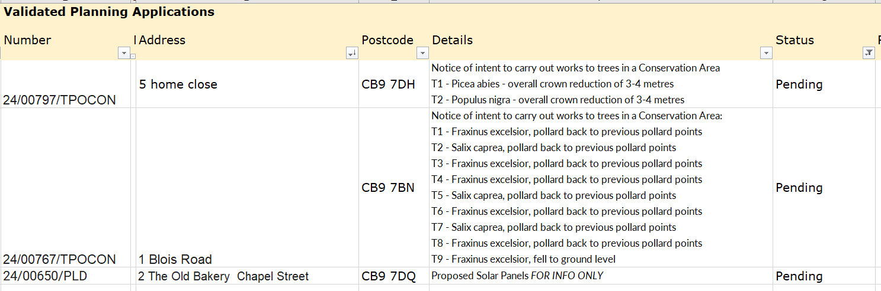

**Decisions**

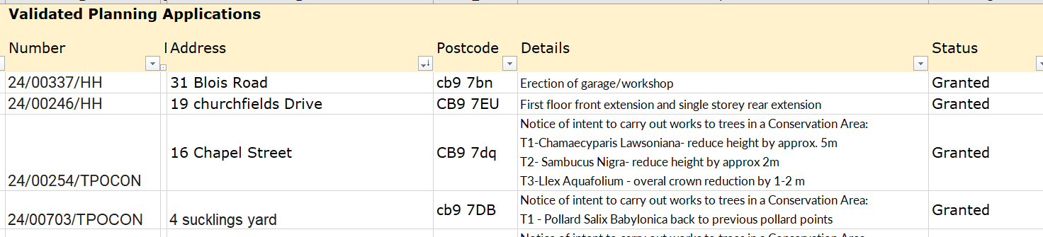

**Other – None at present.**

**24/056 Neighbourhood development plan,** to receive an update **Information**

Come to the end of the consultation period, 6 comments were received. Next BDC will appoint an independent examiner to ensure it is in accordance with BDC Local Plan.

**O T H E R I T E M S F O R D I S C U S S I O N**

**24/057 Closure of Bumpstead road –** Anglian Water is planning to have diversions in place for 4 months. Highways has also scheduled a closure of Finchingfield road. See notes above from Cllr Schwier. There are maps and further information on the PC’s website and Facebook page.

**24/058 Herb and Sensory Planter** –the base to be placed down using eco grid, weed membrane, with 20mm pea shingle added and also levelled. OSWG will meet to go through the plan. The Clerk will order the planter.

**24/059 D-Day 80th Anniversary** – 6th June. Cllr Mackenzie ran through ideas and the general agreement that we will keep this low key. The PC will put up the silent soldiers, purchase some extending trellis and put up the clay poppies at the war memorial and ask the children of the preschool to colour in pictures of poppies to be laminated and put up too.

Cllr Swaby proposed that we purchase a D Day commemorative bench, from David Ogilvie, there was a lot of discussion and the Council decided to review which benches need repair or replacement and not purchase a D-Day bench.

**24/060 Village Showcase and Annual Village Meeting** – with thanks to the Events group

The PC served around 120 slices of cake, used all 90 ‘hot cups’ and moved onto china ones. Would estimate around 250 people were present

**24/061 Councillor Vacancy** – no election will be called by BDC, the PC may advertise the vacancy. The chair suggested that the PC will advertise the vacancy for 2 weeks with a view to co-opt in June or July.

**24/062 Yellow Book Deadline** - 17th May

**24/063 Open Spaces Working group update** – to include scheduling a meeting to update the OS Action Plan

OSWG needs to spend some time going through the forward plan and fleshing out some goals which will lead to budgetary increase next year and also using the s106 funds and looking at grants.

**24/064 Information Sharing –** we have had concerns raised about lack of pedestrian crossings

Cllr Mackenzie – None, Cllr Westrope – none, Cllr Hill – none, Cllr Swaby – Working on Parish Online and getting extra layers from BDC, Cllr Borges – None, Cllr Hexter – new flowers collected for the planter tubs, Cllr Rust – last week a PCSO came to do speed checks, did 52 readings, 5 were speeding to some degree.

**24/065 Meeting Close & Date of Next meeting - Next meeting 13th June. Meeting closed at 22.09**

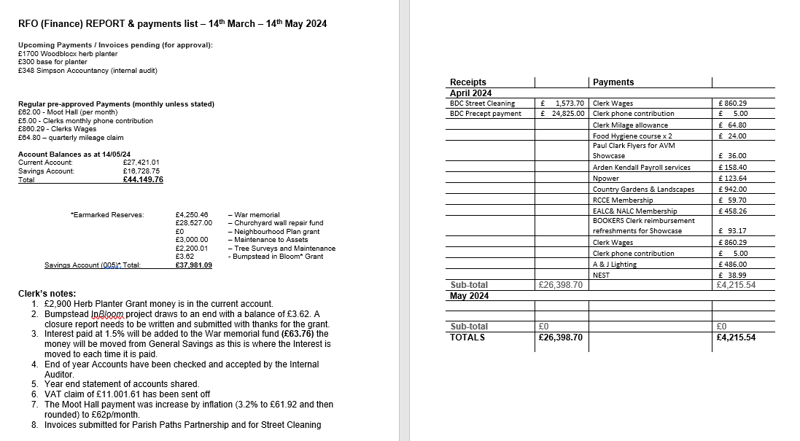

**Signed by Chairman ……………………**

**Date …………………………………………….**