Members of the Council are hereby summoned to attend the
STEEPLE BUMPSTEAD PARISH COUNCIL Meeting @ The Moot Hall
ON Thursday 11th December 2025 at 7.30pm for the purpose of transacting the following business.
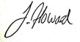
Members of the press and public are welcome to attend.
5th December 2025
Julia Howard, Clerk to Steeple Bumpstead Parish Council
A G E N D A

25/161 Welcome and to receive apologies for absence Chairman
25/162 Declarations of Interest Information
To declare any Disclosable Pecuniary or non-Pecuniary Interest relating to items on the agenda
25/163 To approve the minutes (previously circulated) Decision
of the Parish Council meeting held on 13th November 2025.
25/164 Question Time Information
Public Participation Session with respect to items on the agenda and other matters of mutual interest. Please note: The maximum time allowed for this item is 15 minutes but may be extended at the discretion of the Chairman
25/165 Invitation to Cllr Peter Schwier, Essex County Council and Information
Cllr Diana Garrod, Braintree District Council to address the meeting on matters of mutual interest.
25/166 Mayoral elections 2026 cancelled – to be held in 2028.
25/167 Financial Matters To note and Decision
Item 1. To note receipts and approve upcoming payments
Item 2. Budget setting and precept
Item 3. Cllr training
Item 4. IT Update (.gov emails, MS365 and website) to meet updated SAPP requirements for audit.
25/168 Staffing Matters (Closed Item members of the press and public are asked to leave for the completion of these items and may return afterwards)
25/169 Tree survey- to agree to the quote provided by Caroline Hall Decision
25/170 Training – EALC has a new training provider / name and is offering a wide range of courses
25/171 Planning
Applications –
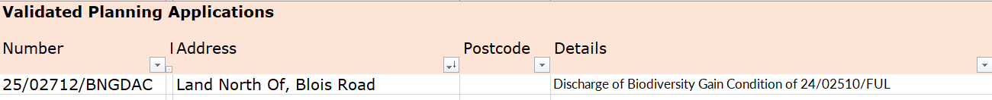

Decisions
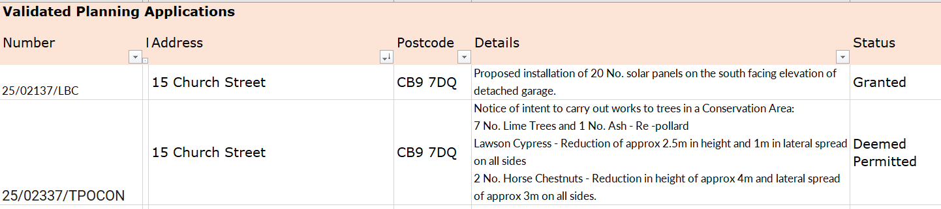
25/172 Actions from Working Groups meeting Decision
25/173 Churchyard Wall working group update Decision
O T H E R I T E M S F O R D I S C U S S I O N `
25/174 Events – Christmas and village showcase
25/175 Road signs around the village
25/176 Update on outstanding actions from previous meeting/s
25/177 Information Sharing
25/178 Meeting Close & Date of Next meeting – 8th January.

