STEEPLE BUMPSTEAD PARISH COUNCIL Meeting @ The Moot Hall, 7.30pm Thursday 13th March 25

Chair: Cllr Kerry Barnes
In attendance: Cllr Swaby, Cllr Hexter, Cllr Rust, Cllr Borges, Cllr Westrope, Cllr Hill, Cllr Mackenzie
Clerk: Mrs Julia Howard
Members of the Public: one

Draft Minutes

25/042 Welcome and to receive apologies for absence – received from Cllr Garrod, Cllr Schwier& Cllr Lacey
25/043 Declarations of Interest - none
25/044 To approve the minutes (previously circulated) of the Parish Council meeting held on 13th February
RESOLVED Cllr Hexter proposed to accept them as a true record, Cllr Rust seconded, all in agreement, by show of hands
25/045 Question Time - One member of the public who is helping to run the library came to give an update, which was very positive, getting more involved with community groups, including doing a monthly tea and chat group. Essex Library service has been helpful in getting some new furniture. There are also some magazines and audio books. The PC is able to offer some financial support towards some additional costs.
25/046 Invitation to Cllr Peter Schwier, Essex County Council and Information
Cllr Diana Garrod, Braintree District Council to address the meeting on matters of mutual interest.
Cllr Garrod’s report is on the website
25/047 Anglian water road closures – an update on the local closures and works Information
Cllr Mackenzie provided a brief update, it has now moved on from Bumpstead and expect to complete later this month, however there are unrelated emergency repairs in the village.
25/048 Planning
Applications -
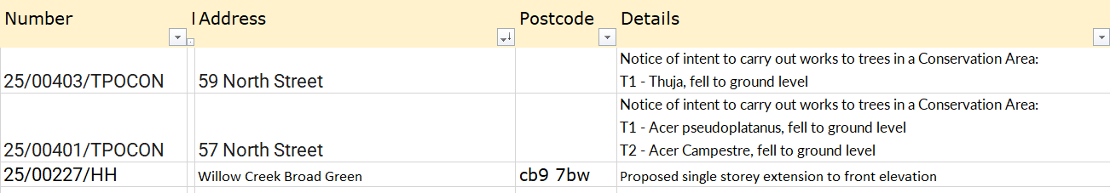
The PC doesn’t typically comment on TPO’s
25/00227/HH - No objection
Decisions –

25/049 Neighbourhood development plan update - Steeple Bumpstead Neighbourhood Plan Referendum is on 3rd April 2025.
Those registered for postal votes will have already received a letter, and a polling card will be sent out in due course. Those not registered for postal votes will be getting the usual information from Braintree District Council and vote. Photographic ID is required for voting. Flyers and Banners have been printed.
The final versions of the plan are available to see in the village shop, library and on the PC’s website.
25/050 Financial Matters To note and Decisions
Item 1. To note receipts and approve upcoming payments as per the financial report plus payments of £51.96 to Clerk for a gift card, £135 printing for NHP plus £90 for the banners. In addition, the Clerk has asked for the PC’s approval to purchase a new notice board at a new cost following the closure of the previous company.
updated prices for a metal Mendip noticeboard is £3299. £3000 was budgeted for the replacement. Cllr Swaby will install the boards.
Cllr Hexter proposal, by show of hands this was resolved. Cllr Hill voted against this spend.
RESOLVED: to purchase notice board and to accept payment report

The Bank reconciliation has been done up to End of February and passed to Cllr Hill for checking.

25/051 Admin Information & Decision
Item 1. Policies – to adopt a new policy called ‘Donation, gifts and hospitality policy’ (circulated)
RESOLVED Cllr Hexter proposed to adopt the policy, Cllr Hill seconded, all in agreement by show of hands – a sign-up sheet sent round for Councillors to confirm they have read and agree to the policy.
Item 2. Annual Audit – for information, the year-end processes commenced this month and will go
through April, with the internal audit. The External audit will follow.
Item 3. Clerks report – an update on previous delegated actions, not much has moved on from last
month, however Zion has now suggested dates to undertake the extra works agreed last month.
Zion have proposed the following dates: Cemetery on Wednesday 19th March to undertake the clearance work.
The churchyard on Wednesday 2nd April to undertake the clearance work. Cllr Hexter will liaise with them.
Item 4. Grants - update on applications and grant reports, incl. s106 & National Lottery
The s106 officer has given the go ahead to complete an application form for the MUGA’s and table tennis table. The Clerk is waiting to hear back from BDC planning, to double check that planning permission is not required to remove and replace the hoops. The Contractor is going to do a final site check on Tuesday and finalise the exact figure. It is expected to use the full s106 funds.
CIF grant – we still have no response; decisions were due in December 24. EALC still say we will hear shortly.
National Lottery / NINJA trail, we are still waiting and expect to hear in April
25/052 Events –VE80 and Village Showcase progress / proposals Decision
Cllr Rust gave an update on the plans for the Showcase 3-5.30pm, setting up from 12.30. All Councillors are asked to be present for the whole session from 12.30. We will need to purchase 3 new banners and refreshments, to be purchased under clerks delegated authority to a maximum of £500
Cllr Mackenzie gave an update on the plans for the VE80 update, with a quiet display of poppies and the silent soldiers around the village.
O T H E R I T E M S F O R D I S C U S S I O N
25/053 Yellow Book deadline – 14th March. Cllr Hexter has drafted this; the clerk will add some further details.
25/054 Amphibian Study at Bell ropes – information on proposed local study. The PC has received an enquiry about setting up an amphibian study, the PC consider that Humphries meadow would be an ideal location and Cllr Hexter will be in touch with the study group.
25/055 Information Sharing – we have had an email for a mobile village supermarket / community larder, which could possibly come to the village. Also cost of living grants available, to be shared to community groups
Another email came enquiring for land or property for a brain injury unit.
Cllr Swaby – is building a shed with bat loft in his garden, does have planning permission for this, Cllr Hexter – none
Cllr Hill – none, Cllr Borges – none, Cllr Westrope – none, Cllr Mackenzie – the wooden post outside the Moot Hall is becoming very wobbly, Cllr Rust – VH update on the refurbishment, new toilets are in. Then the main hall will be refurbished and decorated with new chairs.
25/056 Meeting Close & Date of Next meeting – Annual Parish Meting 26th April, PC meeting 15th May (a week later than usual)
Meeting closed 21.23

