**STEEPLE BUMPSTEAD PARISH COUNCIL Meeting @ The Moot Hall,**

**Thursday 13th February 2025 at 7.30pm**

Chair: Cllr Kerry Barnes

Present: Cllr Hill, Cllr Westrope, Cllr Borges, Cllr Hexter, Cllr Mackenzie and Cllr Rust

Clerk: Mrs Julia Howard

Members of the public: Three (two from Zion)

**MINUTES**

**25/020 Welcome and to receive apologies for absence -** Apologies from Cllr Swaby and Cllr Lacey

**25/021 Declarations of Interest -** To declare any Disclosable Pecuniary, Pecuniary or non-Pecuniary Interest

relating to items on the agenda. Cllr Westrope declares a non-pecuniary interest in item 25/039

**25/022 To approve the minutes** (previously circulated) - of the Parish Council meeting held on 9th Jan 25.

RESOLVED – proposed as a true record by Cllr Hexter, Seconded by Cllr Hill, all in agreement.

**25/023 Welcome to Zion** – our new landscapes contractor

The Chair suspended standing orders to allow Ben and Caroline from Zion Landscapes Ltd to introduce themselves and receive questions from the Council. Clerk to send gate codes to Zion and a bollard key.

Chair officially restarted the meeting at 19.42.

**25/024 Question Time** -Public Participation Session with respect to items on the agenda and other matters of mutual interest. Please note: The maximum time allowed for this item is 15 minutes but may be extended at the discretion of the Chairman. – None. The Members of the public did not wish to speak at this point.

**25/025 Invitation to Cllr Peter Schwier, Essex County Council and Cllr Diana Garrod, Braintree District**

**Council** to address the meeting on matters of mutual interest.

Cllr Schwier gave his report, ECC’s Council tax rise was 3.35% the lowest rise in the Country. Further updates have been sent by email throughout the month. New Chief Executive, Nicole Wood was confirmed. SCRAP project for enforcements on fly-tipping the campaign also focusses on better ways to dispose of items including batteries, clothing, large items. Through Love Essex newsletter micro grants have been launched. ECC has been put on the priority list for Devolution. May 25 elections have been postponed, with mayoral elections in 2026, further elections will follow.

Cllr Garrod gave her report (which is on the PC’s Website) which included a number of road closures including;

**Intended closure of Bumpstead Road from 24th February to 28th March 2025 whilst Anglian Water undertakes mains replacement.** [https://one.network/?tm=140902069](https://gbr01.safelinks.protection.outlook.com/?url=https%3A%2F%2Fone.network%2F%3Ftm%3D140902069&data=05%7C02%7Ccllr.dgarrod%40braintree.gov.uk%7Cdf02d6992104452ce90b08dd41dc909d%7C25f7dc6a2f004c05bf5b651e113d3f16%7C0%7C0%7C638739137755784958%7CUnknown%7CTWFpbGZsb3d8eyJFbXB0eU1hcGkiOnRydWUsIlYiOiIwLjAuMDAwMCIsIlAiOiJXaW4zMiIsIkFOIjoiTWFpbCIsIldUIjoyfQ%3D%3D%7C0%7C%7C%7C&sdata=qBU5dyOatu7u2BaefH59AlGwPJMnY7p6wQ8l76%2Bz7CQ%3D&reserved=0)

Intended closure of Sturmer Road and Hill Lane, Maltings Lane, The Endway (access only) 11th March 2025 9am-4pm whilst UK Power Networks undertakes pole replacement.

**McDonalds litter is becoming a nuisance, with the village litter pickers having collected 15 bags of litter, the majority of which is from the fast-food chain.**

**25/026 Proposals for VE Day 80 – Thursday 8th May 2025** – Suggestions for agreement - St Mary’s are holding events on 10th May at the village hall. The PC could go ahead with a small service in Church Street and the Beacon lighting and a song to be sung and possibly opening up the Moot Hall with some historical displays or in the Yellow Book as an article – to be confirmed at March meeting.

**25/027 Anglian water road closures** – an update on the local closures and works – We are nearing the end of the worst of the disruption, but works are still on going. The recent discolouration of the brook was due to disruption of sediment below, and not contamination.

**25/028 Planning**

**Applications – None**

**After the agenda was posted we have received 2 applications**

**25/00059/HH** 5 Sucklings Yard Steeple Bumpstead Essex CB9 7DB - Replacement of existing softwood timber windows with aluminium windows. Removal of existing render to front and rear elevations (only) and replacement with low maintenance fibre cement weather boarding.

**25/00227/HH** - Willow Creek Broad Green Steeple Bumpstead Proposed single storey extension to front elevation

Planning working group to review these.

**Decisions - None**

**25/029 Neighbourhood development plan,** to receive an update - Referendum date is not confirmed

but may be as soon as 3rd of April. This is arranged by BDC. PC would like to do a leaflet drop if permitted.

**25/030 Financial Matters To note and Decisions**

**Item 1.** To note receipts and approve upcoming payments

RESOLVED Cllr Rust proposed to accept the report and approve payments, Cllr Mackenzie seconded and all agreed

**Item 2.** Update on Notice Board action & funding to Library – the Clerk is working to find a suitable alternative noticeboard following the closure of the previous company. Updates will be by email. The Clerk suggested that the library honorarium is turned into a grant or earmarked account which can be used to pay for additional expenses in offering this service. This seems favourable and the clerk will liaise with the library

**25/031 Admin Information & Decision**

**Item 1. gov email addresses, website and cyber-security** - Decision on change of accounts

Not resolved as yet

**Item 2**. **Clerks report –** an update on previous delegated actions, report circulated including

Policies for approval – Bench donation policy, Grant Awarding Policy and Communication Policy.

RESOLVED Cllr Hexter proposed to accept them, seconded by Cllr Hill all in agreement. The signing sheet was circulated to be signed by the Councillors.   
**Item 3**. **Grants** - update on applications and grant reports, incl. s106 – the CIF grant decision has not been made yet. The previous CIF grant report is due – Cllr Mackenzie is drafting this.

s106 – Caloo has visited and quoted for the specification we put forward (circulated), it has been send to the s106 officer for approval.

RESOLVED Cllr Hexter proposed that the PC should go forward with this providing that BDC approves for s106 funding, Cllr Mackenzie seconded all were in agreement.

**Item 4**. **Emergency Plan** – this has been accepted by BDC - Clerk to email full copy out to Councillors.

Cllr Lacey to do public version and send to Clerk and whoever else needs a copy.

**25/032 War Memorial –** consideration of remedial works required – in hand with Cllr Westrope

**25/033 Flood Initiatives Group** – update following first meeting of the group - Terms of Reference agreed, notes to be circulated. Cllr Mackenzie has spoken to one of the farmers regarding digging out the ditch to assist with water flow. 5 people were in attendance.

**25/034 Open Spaces Working group update** – to share status updates on all areas

RESOLVED To Approve Zion Quotes as follows;

Closed Churchyard tidy-up £754+Vat, and tree work (subject to permissions and cost of replacement trees) estimated at £1530+VAT

And Cemetery Overhaul £1130+VAT.

Discussions about where the funds would come from. Clerk advised there are funds available within the 24/25 budget. Chair Cllr Barnes proposed to proceed with both quotes (3 parts) and Cllr Hexter seconded, all voted in favour.

**Item 1. To ratify the approval of Footpath 12 change of route** – the change of route is to the route RESOLVED currently in use and is a paperwork exercise. The Council is an agreement.

**Item 2. To consider the purchase and installation of a fire Beacon –** If a grant is available the PC would like to move forward with this. There is a space identified on the Camping Close towards St Mary’s churchyard, which would be ideal when linked with a church service. The PC would prefer to opt for a traditional tall version with a timber post and would prefer to be a gas fired beacon.

**Item 3. Bench donation enquiry –** we have an enquiry, Chair Barnes will liaise with interested party. They have had the Bench donation policy but will need advice.

**Item 4. Gate to Churchyard from Camping close requires maintenance**

The gate post requires replacing and then the gate to be rehung. Rev Lowe has confirmed the PC can go ahead with this; Sybil has said we will need to advise the DAC (Diocese) there is historic importance to the gate. A volunteer has offered to replace the post, the PC will pay for the post. Cllr Hexter to liaise.

**25/035 Events** – Christmas tree review update, VE80, Village Showcase and Bumpstead day progress - Village showcase update Cllr Rust, Cllr Hexter, Cllr Mackenzie and the Clerk form the working group. On 13th March pre-meet to allocate duties for the showcase. Anglian water could come and/or have a stand, Cllr Mackenzie will speak to them.

As Bumpstead Day isn’t going ahead Cllr Hexter suggested a or some smaller events proposals / fund raising i.e. A fete, band in the hall, fish and chip supper, barn dance etc with funds towards a specified goal i.e. the zip wire. This was well received and the events group will form a plan, with Cllr Hexter taking the lead on forming it.

**O T H E R I T E M S F O R D I S C U S S I O N**

**25/036 New Play area now open** – Eastlight Community Housing has opened the North Crescent

play area. It was a fantastic event in inclement weather, photos and news articles in the papers.

**25/037 Essex Fire Team visits** – On 15/01/25 they visited to door knock and check smoke detectors

The team door knocked on 163 Houses engaging with 67 properties gaining 11 referrals for smoke alarms and completed x4 Home Fire Safety Checks.

 The Roads covered were North Street/Freezes Barns/North Crescent/Claywell Bridge &Cottages/Blois Road/Chapel Street/Lion Meadow and The Chase.

**25/038 Planting by Bellropes/Tanyard** – final update on this item, not for discussion.

A report has been circulated following the advice of the Monitoring Officer.

The report will be available to the public and if in due course parties cannot agree terms and both sign a formal agreement then the hedge will be removed and the area reinstated, by the PC and at the cost of the PC.

**25/039 Closure of the Post office** – for information. An email confirming the closure was circulated to the Councillors, Cllr Westrope will enquire as to whether a mobile post office could come to the village. The Council agreed to purchase a small gift by way of thanks.

The Parish Council would like to thank Jess Bruce for all her work as Post Master.

**25/040 Information Sharing –** Cllr Rust- the VH refurbishment is working well, Cllr Mackenzie – the oak post outside Moot Hall is worsening, Cllr Borges – is there any progress on the Churchyard wall, awaiting revised quote for sections, Cllr Hill – Clements Surgery PPG meeting on Monday explained that all medical calls have moved to the Axa building merged with Long Melford and Lavenham 30k patients, freeing up the surgery for usual appointments, the e-consult response times are now 1 hour (except on Mondays), Cllr Westrope – a stair gate has been dumped in the river by the Crescent.

**25/041 Meeting Close & Date of Next meeting** – 13th March, meeting closed at 22.02

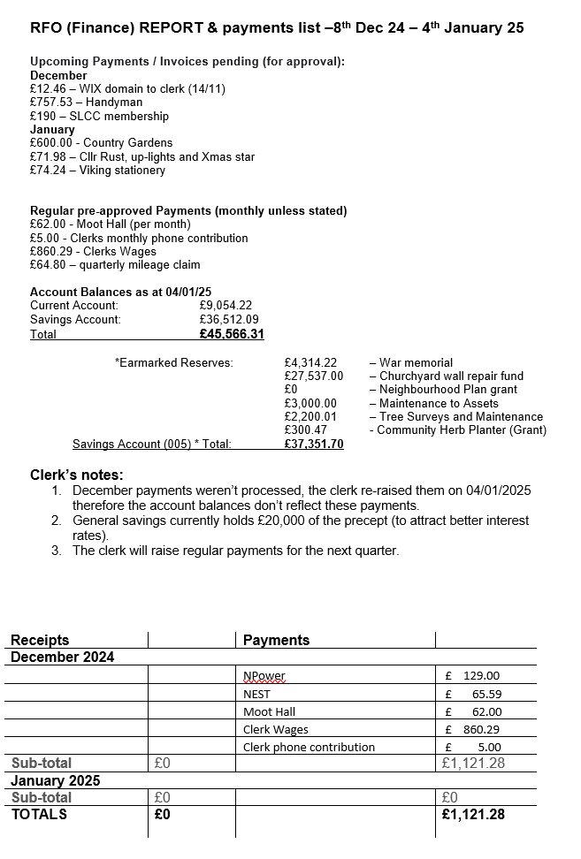

**Signed by Chairman ……………………**

**Date …………………………………………….**