**Members of the Council are hereby summoned to attend the**

**STEEPLE BUMPSTEAD PARISH COUNCIL Meeting @ The Moot Hall**

**ON Thursday 9th October 2025 at 7.30pm for the purpose of transacting the following business.**

**Members of the press and public are welcome to attend.**

4th October 2025

Julia Howard, Clerk to Steeple Bumpstead Parish Council

**A G E N D A**

**25/131 Welcome and to receive apologies for absence Chairman**

**25/132 Declarations of Interest Information**

To declare any Disclosable Pecuniary or non-Pecuniary Interest relating to items on the agenda

**25/133 To approve the minutes** (previously circulated) **Decision**

of the Parish Council meeting held on 11th September 2025.

**25/134 Question Time** **Information**

Public Participation Session with respect to items on the agenda and other matters of mutual interest. Please note: The maximum time allowed for this item is 15 minutes but may be extended at the discretion of the Chairman

**25/135 Invitation to Cllr Peter Schwier, Essex County Council and Information**

**Cllr Diana Garrod, Braintree District Council** to address the meeting on matters of mutual interest.

**25/136 Bus services Consultation –** removal of 320/321, consultation closes on 27/10 **Information**

**25/137 FIDO BAGS** – follow up from last meeting

**25/137 Financial Matters To note and Decision**

**Item 1.** To note receipts and approve upcoming payments

**Item 2.** Audit update

**Item 3.** IT Update (.gov emails, MS365 and website)to meet updated SAPP requirements for audit.

**25/138 Planning**

**Applications - none**

**Decisions**

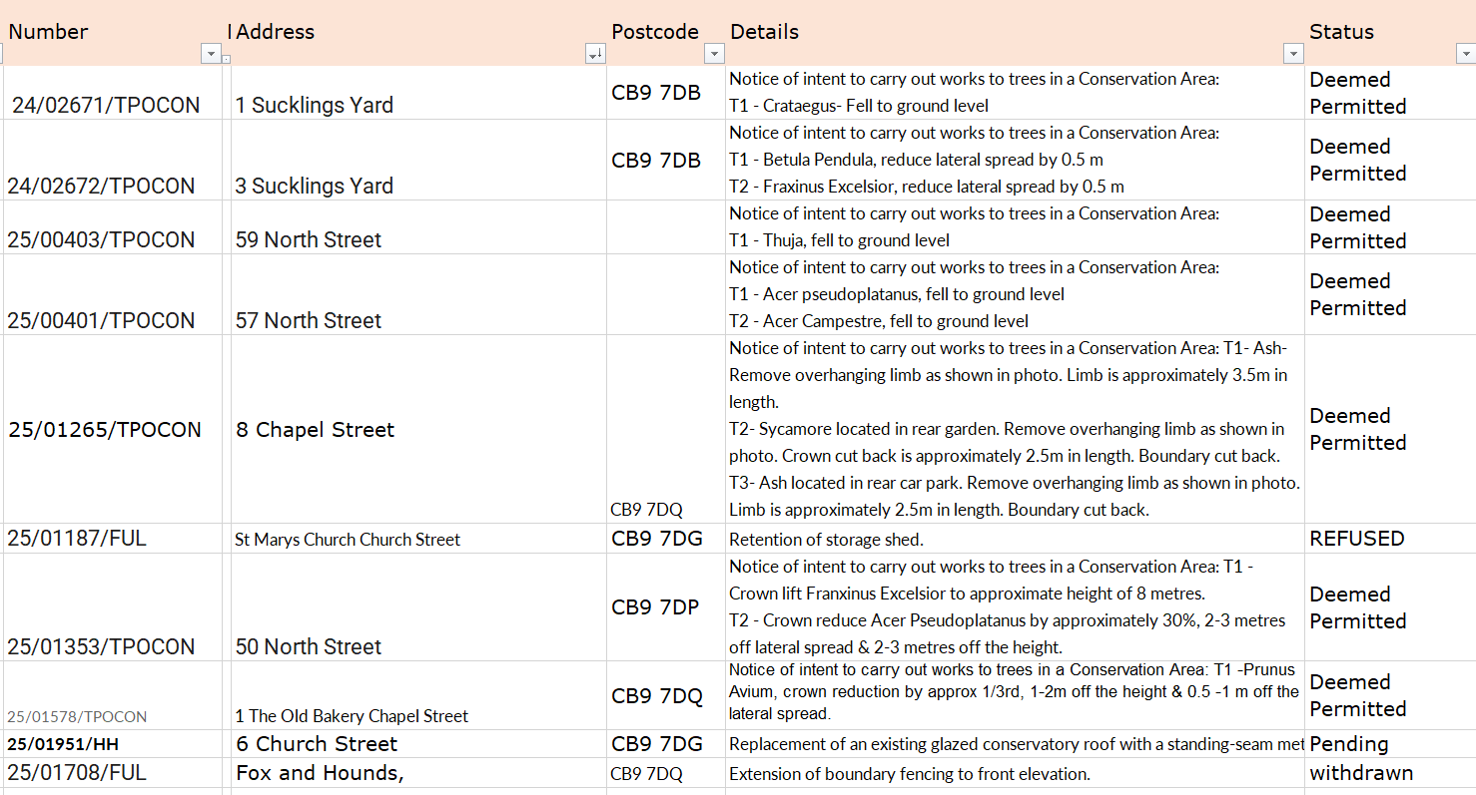

**Other – None at present.**

**25/139 Abandoned Heras fencing**

**25/140 Actions from Working Groups Decision**

**25/141 Churchyard Wall working group update Decision**

**O T H E R I T E M S F O R D I S C U S S I O N**

**25/142 Events – Christmas Planning and Remembrance Day**

**25/143 Update on outstanding actions from previous meeting/s**

**25/144 Information Sharing**

**25/145 Meeting Close & Date of Next meeting –** 13th November.