**District Councillor's Report to Parish Councils May 2025**

**Cllr. Diana Garrod - Bumpstead Ward**

**Scheduled Temporary Traffic Regulation Orders & Roadworks**

Intended closure of North Street, Steeple Bumpstead. Commencing 18th May 2025 for 1 day whilst Cadent undertakes new connection. [https://one.network/?tm=142270013](https://gbr01.safelinks.protection.outlook.com/?url=https%3A%2F%2Fone.network%2F%3Ftm%3D142270013&data=05%7C02%7Ccllr.dgarrod%40braintree.gov.uk%7C2644775ee4224480895e08dd817d6497%7C25f7dc6a2f004c05bf5b651e113d3f16%7C0%7C0%7C638809097738249002%7CUnknown%7CTWFpbGZsb3d8eyJFbXB0eU1hcGkiOnRydWUsIlYiOiIwLjAuMDAwMCIsIlAiOiJXaW4zMiIsIkFOIjoiTWFpbCIsIldUIjoyfQ%3D%3D%7C0%7C%7C%7C&sdata=UNb4718JIbzV83BOe54kXNNoJZlZtHboZs15qdPmcjY%3D&reserved=0)

Intended closure of Water Lane, Sturmer. Commencing 19thMay 2025 for 6 nights 20:00-05:00 whilst Essex County Council undertakes machine surfacing.  [https://one.network/?tm=141939616](https://gbr01.safelinks.protection.outlook.com/?url=https%3A%2F%2Fone.network%2F%3Ftm%3D141939616&data=05%7C02%7Ccllr.dgarrod%40braintree.gov.uk%7C916a72c74642418b4ad908dd889f4a6b%7C25f7dc6a2f004c05bf5b651e113d3f16%7C0%7C0%7C638816939922520828%7CUnknown%7CTWFpbGZsb3d8eyJFbXB0eU1hcGkiOnRydWUsIlYiOiIwLjAuMDAwMCIsIlAiOiJXaW4zMiIsIkFOIjoiTWFpbCIsIldUIjoyfQ%3D%3D%7C0%7C%7C%7C&sdata=O50Dwhrmr10EvDQIzDh1a3QjGUxiKcHnH%2BK3Ld7V2MQ%3D&reserved=0)

Multi-way traffic signal at New England, Sturmer Road. Commencing 1st May to 24th October 2025 for Utility Asset Works. Anglian Water. Project: SEW-12079 - Stambourne P Pump Away Scheme (see below)

**Anglian Water – Works at New England Ref No. 64336411**

Affected area: New England Start Date: 22 April 2025 Estimated restoration: 17 October 2025

***We're investing in your local community to prevent flooding***

*You may know we recently completed a project laying new pipes between Stambourne and Birdbrook.*

*As part of that £1.4 million investment, we’re about to start another project to upgrade the sewer system in New England, helping protect homes and the environment from flooding.*

***What’s happening in your area?***

*We'll be installing new underground storm water storage pipes in the field opposite Sturmer Road in New England. The new system will improve drainage in your area and help to reduce the risk of flooding during heavy rain. We're due to start work on 22 April and if everything runs smoothly, we'll be finished by October 2025.*

***How will the work affect you?***

*Because you live nearby, you’ll see and hear us working and you can expect to see machinery and heras fencing surrounding the site for the duration of the project.*

*The team will arrive quietly at our temporary site compound from around 7am to attend daily briefings and set up for the day. Work will start between 8am and 8:30am, we will aim to finish by 5pm each day. We don’t currently plan to work weekends but if this changes, we’ll let you know. As part of our work, we’ll be using sheet piling to support the area around the excavation. This allows us work safely below ground. We plan to start piling in May, and it will be completed it in two phases, each lasting around two to three weeks. This can be subject to change, so we’ll be back in touch again closer to the time. We know this can be noisy, so we really appreciate your patience and understanding and thank you for bearing with us while we carry out this important step. When we’re working on complicated projects like this there's always likely to be some disruption for local residents, and we'd like to thank you and your whole community in advance for bearing with us while we work. Don't worry, none of our work will affect your water supply or toilet facilities. Once work is complete, we’ll finalise**arrangements with the landowner regarding their preferences for restoration.*

***Managing traffic during our work***

*We always try to keep disruption to a minimum, but the safety of our staff and the public is our top priority. To help with this, we’ll be using 3-way traffic lights between Sturmer Road and Blois Road. They’ll only be in place between 9:30am and 3:30pm and used when we expect larger deliveries. At all other times, traffic will flow as normal and the lights will stay green.*

*Our plans may change depending on how the work progresses, so you can always check the latest updates at* ***anglianwater.co.uk/check****.*

*If you have any questions about our work, you can email us at* ***onealliancecustomers@anglianwater.co.uk*** *or call us on* ***03457 145 145****.*

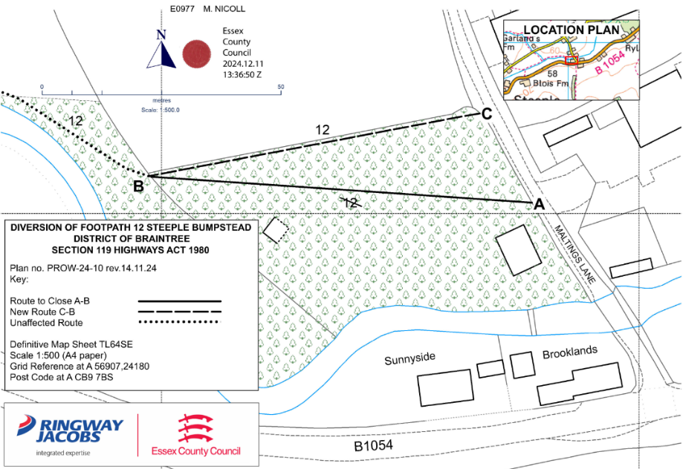**Public Footpath Diversion Order: Footpath 12 Steeple Bumpstead**

The PROW over the land situated at Brooklands known as Footpath 12 Steeple Bumpstead. Show by a bold continuous line on the order map numbered PROW-24-10 rev 14.11.24 shall be stopped up after 35 days.

At the end of 28 days there shall be a public footpath over land situated at Brooklands known as Footpath 12 Steeple Bumpstead, shown by a bold broken line on the order map PROW-24-10 rev 14.11.24.

**Stambourne Swimming Pool Receives Grant**

Spring Croft swimming pool in Stambourne has extended its venue thanks to a £36,350 grant awarded by Braintree District Council from the UK Government’s Rural England Prosperity Fund. The new extension has transformed the venue into a community hub creating more space and opportunities for the local community. The new space includes a multi-use changing room, a small office, a customer service counter and a versatile function room and viewing area. The grant contribution supported the delivery of this extension, but its completion was only made possible thanks to additional investment from the venue itself. The new community hub is now open to customers. Visit  [www.swim4life.co.uk/](https://gbr01.safelinks.protection.outlook.com/?url=http%3A%2F%2Fwww.swim4life.co.uk%2F&data=05%7C02%7Ccllr.dgarrod%40braintree.gov.uk%7C431caf1c1910477ef0a608dd864a3f8a%7C25f7dc6a2f004c05bf5b651e113d3f16%7C0%7C0%7C638814375801090458%7CUnknown%7CTWFpbGZsb3d8eyJFbXB0eU1hcGkiOnRydWUsIlYiOiIwLjAuMDAwMCIsIlAiOiJXaW4zMiIsIkFOIjoiTWFpbCIsIldUIjoyfQ%3D%3D%7C0%7C%7C%7C&sdata=y8nIHpACEe4wSpyzOElE1sFMsx50HGtHHJxXLZmtzkQ%3D&reserved=0)

**Stansted Airport Solar Farm – Update**

Stansted Airport says … *The 14.3MW solar farm, will be the first of its kind at a London airport and will be on land already owned by Stansted immediately to the east of the airport at High House Farm. The development is designed to meet current and increasing electricity demands, including from the growing use of electric vehicles, and will support them in their commitment to make operations net zero carbon by no later than 2038. The output of the farm at its peak, on the sunniest days of the year, will provide the equivalent energy consumed by around 6,000 homes, a similar number of households to the town of Saffron Walden! The project will also include the enhancement of biodiversity on site and the implementation of additional screening measures, such as the planting of over 50 new Willow and Field Maple trees, hedgerow reinstatement and 750 metres of new hedgerows plus a 19 hectare wildflower meadow.*

**Local Plan Review - 2041**

Local Plan Sub Committee meetings are scheduled to take place in May, June, July and September in advance of the Regulation 18 consultation. These meetings will consider sites put forward for development. Sites will be grouped by ward to enable interested parties to join meetings based on areas of interest. The following table shows current plans for each meeting to give an indication of which sites are currently anticipated to be discussed at each meeting. Please be advised that this schedule may be subject to change for a variety of technical reasons. Therefore, it is recommended that anyone following sites in a particular area consults the published agenda to be certain that areas of interest will be discussed as set out below. As you will be aware, some of the sites put forward are large scale/strategic scale sites (or, when combined with neighbouring sites, would deliver a development of this scale). Owing to the need for bespoke technical work to support an assessment of strategic scale developments, these will 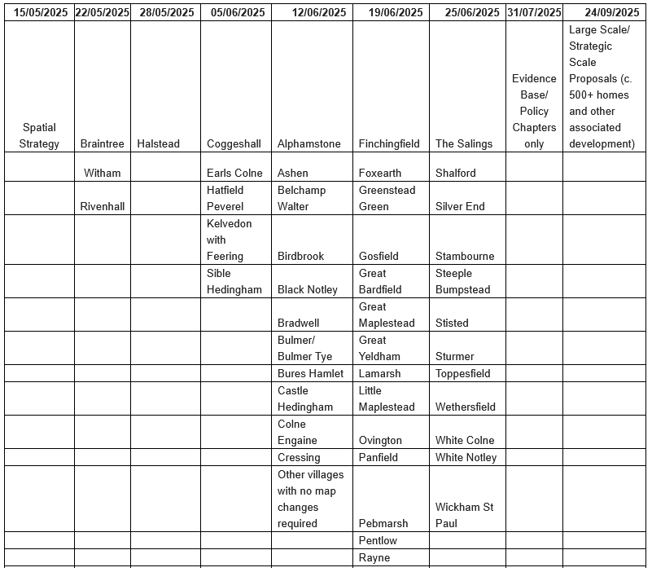not be considered until 24 September 2025 meeting. Where an area is listed at an earlier meeting (e.g. Halstead on 28 May 2025), the sites considered will be smaller scale sites only.

**Local Spillage Spills (Discharges)**

The Rivers Trust has now updated their sewage map to include the 2024 annual summary data for sewage spills (planned discharges). <https://theriverstrust.org/key-issues/sewage-in-rivers> Examples:-

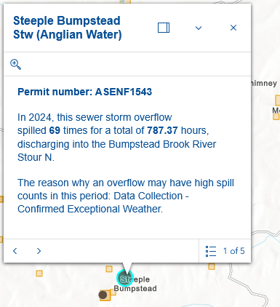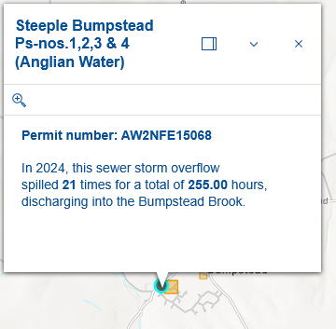

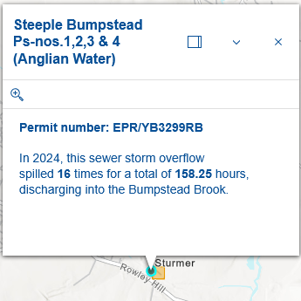

(For comparison purposes: Foxton, Cambs - sewer storm overflow spilled **188** times for a total of **4,487.00** hours, discharging into the River Rhee. Teversham, Cambs - sewer storm overflow spilled **167** times for a total of **3,182.43** hours, discharging into the Quy Water Bottisham Lode. Both – Anglian Water).

**Cllr**. Diana Garrod

Braintree District Councillor - Bumpstead Ward