STEEPLE BUMPSTEAD PARISH COUNCIL Meeting @ The Moot Hall ON Thursday 11th December 2025 at 7.30pm for the purpose of transacting the following business.

Chair: Cllr Kerry Barnes
In attendance: Cllr Westrope, Cllr Mackenzie, Cllr Aldred, Cllr Rust & Cllr Hill
Clerk: Mrs Julia Howard
Members of the Public: none

DRAFT Minutes

25/161 Welcome and to receive apologies for absence - Apologies from Cllr Borges, Cllr Swaby, Cllr Lacey, Cllr Schwier & Cllr Garrod
25/162 Declarations of Interest - none
25/163 To approve the minutes (previously circulated) of the Parish Council meeting held on 13th November
RESOLVED by show of hands.
25/164 Question Time -none Information
25/165 Invitation to Cllr Peter Schwier, Essex County Council and Information
Cllr Diana Garrod, Braintree District Council to address the meeting on matters of mutual interest.
The reports are on the PC’s website. The PC took a moment to speak about some aspects of the report, including planning and recycling.
25/166 Mayoral elections 2026 cancelled – to be held in 2028. This is a central government decision. The District and County elections may therefore resume in the meantime, but this has not yet been confirmed.
25/167 Financial Matters To note and Decision
Item 1. To note receipts and approve upcoming payments –
As per report plus £14 for herb planter
RESOLVED Proposed to approve by Cllr Rust, Seconded by Cllr Hill, all in agreement by show of hands
Item 2. Budget setting and precept –a PowerPoint explaining this has been circulated. The Chair explained the key points and answered some questions. The PC was happy with the budget proposal and will vote on the precept figure at the January PC meeting.
Item 3. Cllr training – Cllr Aldred is looking into the Cllr training to be delivered in Bumpstead.
Item 4. IT Update (.gov emails, MS365 and website) to meet updated SAPP requirements for audit.
The website is ready to go live; the domain has been requested. The WIX payment has just come out. When the new domain is confirmed, we can put a redirection on Wix for the remainder of the term. New email addresses will then be arranged.
25/168 Staffing Matters (Closed Item members of the press and public are asked to leave for the completion of these items and may return afterwards)
Item 1. RESOLVED it was agreed to advertise for an assistant handyman for 2hrs/week for 3 months at £350 max for
the role. Proposed by Cllr Rust, Cllr Mackenzie seconded all in agreement clerk to advertise the role to start in
February.
Item 2. RESOLVED it was agreed Cllr Mackenzie will attend staff probationary reviews / appraisals.
Item 3. RESOLVED Chair Cllr Barnes proposed that the clerk provides 8 weeks’ notice instead of the 4 weeks in her
Contract, this should allow for more consistency throughout the recruitment process. Seconded by Cllr Mackenzie all
In agreement.
Chair Cllr Barnes decided to arrange a meeting of the personnel WG to discuss advertising of the role. The clerk
advised that the PC as a whole need to make decision on the aspects listed in earlier emails, i.e. hours, salary range,
contract terms and recruitment process.

25/169 Tree survey- to agree to the quote provided by Caroline Hall Decision
RESOLVED Proposed to go ahead with this quote by Cllr Rust, Seconded by Cllr Aldred, all agreed by show of hands. Quote of £995 + VAT, this needs to be accepted before the end of the year to stay at this cost.
25/170 Training – EALC has a new training provider / name and is offering a wide range of courses, Councillors are asked to advise the clerk if they would like to attend any of these courses.

25/171 Planning
Applications –
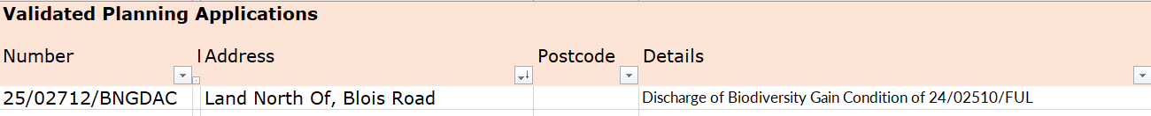
Cllr Hill is going to look into this further and advise the clerk on how to respond.

Decisions
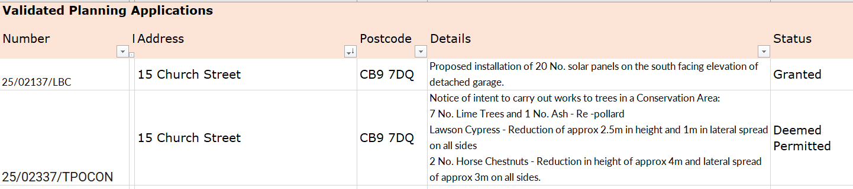
25/172 Actions from Working Groups meeting
Grit bins – Cllr Mackenzie is due to speak to the shop and the resident near the Endway regarding locating two new grit bins, the base for salt storage has been done, the bench base is down and bench has been delivered and plans to be installed next week. Post office – not had any success as yet in getting a mobile service for the village, the Chair will speak to the area co-ordinator. Measurements for the trim trail / climbing frame area – Cllr Rust is looking into this. Plaque holders have been made for the avenue of memorial trees, plaques need to be engraved and Cllr Mackenzie will speak to the Vets Football club about these before arranging to install them. The PC also needs to have a meeting with a representative of each of the Football clubs / teams, to ensure our facilities meet their needs and we can work well together, we’d like to do this annually or every 6 months and to update terms of reference. Cllr Aldred met with Zion and looked at the hedge, which they will review again in the spring.
25/173 Churchyard Wall working group update - AFP has been commissioned to do a survey and we are waiting for this to happen and a report from them.
O T H E R I T E M S F O R D I S C U S S I O N
25/174 Events – Christmas and village showcase – The Christmas event was very well received, and was done very safely. It is the first to not be cost neutral, however some spend was for equipment for future events, we are still waiting for some donations to come in. The review of this needs to be done in Jan / Feb, which includes setting the date/time of the next Christmas event, which has been considered in the de-brief on the day.
Village Showcase planning needs to start now /January, date Saturday 18th April at 2pm and the events WG will arrange this.
25/175 Road signs around the village – The village shop has noticed a drop in trade due to the closed roads; however, the roads were not closed, and the area of road works was very small. The financial impact is significant, along with the disruption to residents and those travelling through / around the village.
25/176 Update on outstanding actions from previous meeting/s
25/177 Information Sharing – Cllr Westrope-none, Cllr Mackenzie -none, Cllr Aldred – none, Cllr Hill – enquired how long it will take to complete the play area repairs, most have been done now, just waiting for the swings to be put back up Cllr Rust – none.
25/178 Meeting Close & Date of Next meeting – 8th January. Meeting closed at 21.05.

