STEEPLE BUMPSTEAD PARISH COUNCIL Meeting @ The Moot Hall Thursday 9th October 2025 at 7.30pm

Chair: Cllr Kerry Barnes
In Attendance: Cllr Aldred, Cllr Borges, Cllr Mackenzie, Cllr Lacey, Cllr Westrope, Cllr Rust, Cllr Hill & Cllr Garrod
Clerk: Mrs Julia Howard
Members of the Public: none

DRAFT Minutes

25/131 Welcome and to receive apologies for absence - apologies received from Cllr Swaby & Cllr Schwier
25/132 Declarations of Interest - Cllr Westrope non-pecuniary interest re: finance
25/133 To approve the minutes of the Parish Council meeting held on 11th September 2025.
RESOLVED Proposed by Cllr Lacey, seconded by Cllr Hill, all in agreement by nod of head.
25/134 Question Time - none.
25/135 Invitation to Cllr Peter Schwier, Essex County Council and Information
Cllr Diana Garrod, Braintree District Council to address the meeting on matters of mutual interest.
Cllr Garrod summarised her report, which is on the PC’s website.
There will be an extraordinary meeting of Full Council scheduled Monday 24th November for the Local Plan and there will be no other business considered at this meeting.
EA has just put out a new Flood Risk map.
25/136 Bus services Consultation – removal of 320/321, consultation closes on 27/10 Information
We have been really well supported by Cllr Garrod and Cllr Schwier, the clerk also wrote in a letter as agreed and the public consultation appeared in 2 places in the Yellow book, it’s on the PC’s website and FB page and the residents FB page. We urge residents and those affected, from Haverhill and Safron Walden to also respond to the consultation.
25/137 FIDO BAGS – follow up from last meeting. The Clerk put together a costing report and Cllr Barnes spoke to the resident who raised it, it would be quite costly and is unlikely to resolve the issue of bags being left on branches and fences and may have no impact on clearing of messes. The PC agreed to put this on hold for moment.
25/137 Financial Matters To note and Decision
Item 1. To note receipts and approve upcoming payments. A bank reconciliation has been passed to Cllr Hill to review.
RESOLVED Proposed by Cllr Lacey seconded by Cllr Mackenzie, all agreed by show of hand.
Item 2. Audit update – the completed audit is on the PC’s website with the closure report.
Item 3. IT Update (.gov emails, MS365 and website) to meet updated SAPP requirements for audit.
We have instructed Parish Council Websites to create our new website and .gov email addresses. A deposit is due.

25/138 Planning

Applications
No objection to this.

Late addition –
25/02137/LBC - 15 Church Street, CB9 7DQ. Proposed installation of 20 No. solar panels on the south facing elevation of detached garage.
The PC supports this as a sustainable addition to the property and it won’t be visible from the roadside.

Decisions
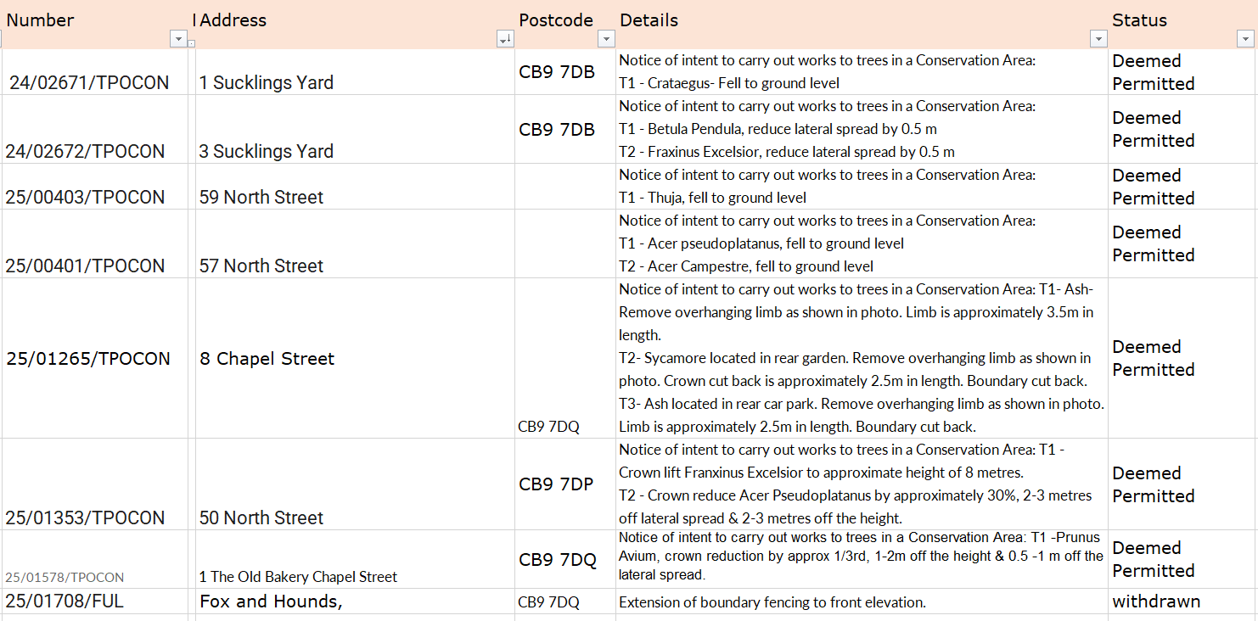

25/139 Abandoned Heras fencing at Poppyfields– raised by a member of the public as now
causing more risk than not having it there at all. This is a result of the abandoned work to the pavement at that location, due to the builders’ company collapsing. Chair Cllr Barnes has raised this with a planning officer at BDC, who is going to look into it and come back to Cllr Barnes.
Chair Cllr Barnes will ask Zion if they’d like to take them – then they may be reused rather than disposed of.
25/140 Actions from Working Groups Decision
The next all working groups meeting is at 6.15 pm directly before the November PC meeting.
Update on the zip wire, we can commission ROSPA to do a noise survey, the Clerk will enquire about this. The PC will also arrange for some signage to be put in place, reminding people that neighbours live nearby. The Open Spaces working group will also do some spot checks on the levels of noise in the area at a variety of times.
25/141 Churchyard Wall working group update Decision
Cllr Swaby to advise – Chair Cllr Barnes to follow up with Cllr Swaby and then update the clerk on next actions.
O T H E R I T E M S F O R D I S C U S S I O N
25/142 Events – Christmas Planning and Remembrance Day
Remembrance Day – Cllr Westrope is arranging the usual tidy up of the Memorial and the relevant headstones. Crochet poppy donations are still welcomed and will be added to the display either this year or next year.
Christmas tree– Cllr Lacey held the second meeting. Plans are in place building on the event last year, and will be held at the Village Hall. We’d like to have a lantern procession too – watch the FB and Website for more on this. No Flames / fire permitted and all lanterns to be taken home and disposed of responsibly.
Spending by the PC will be approximately £30 for candy canes, £40 for decorations, £35 additional light set, £10 backdrop for Santa. There will also be a bar, food vendor, ice cream van and Portobello Coffee.
Advent windows – we’ve had our first two people sign up, please let the Clerk know if you’d like to participate – send an email with your preferred date.
25/143 Update on outstanding actions from previous meeting/s
1. Donation of bench – a parishioner has now paid for the memorial bench to replace an old bench on the camping close; this will move forward now 2. Storage of the winter salt – will be done when the bench goes in, 3. Noticeboard removal / installation, this has been done, but it is awaiting the damaged paving slabs to be replaced / re-laid. 4. Gate at churchyard – waiting for a tree to be cut back first, requires a faculty for this
25/144 Information Sharing
Cllr, Aldred – None, Cllr Borges – none, Cllr Mackenzie – none, Cllr Lacey – none, Cllr Westrope – rubbish at the camping close, from a householder’s garden/drive area, The Moot Hall plans to put lighting on the building, Cllr Rust – none, Cllr Hill – none, Cllr Barnes – none
25/145 Meeting Close & Date of Next meeting – 13th November. Meeting closed at 21.04

