STEEPLE BUMPSTEAD PARISH COUNCIL Meeting @ The Moot Hall ON Thursday 8th February 2024 at 7.30pm

Chair: Cllr Borges
Present: Cllr Swaby, Cllr Westrope, Cllr Hexter, Cllr Rust
Cllr Schwier, Cllr Garrod,
Clerk: Mrs Julia Howard
Two members of the public

MINUTES
24/014 Welcome and to receive apologies for absence Chairman
With the Council’s chairman and vice chair absent, Cllr Rust proposed that Cllr Borges chair the meeting, Cllr Westrope seconded and all voted in agreement.
Apologies were received from Chairman Cllr Barnes, Cllr Hill, Cllr Denning and Cllr Mackenzie.
24/015 Declarations of Interest - none Information
24/016 To approve the minutes (previously circulated) - of the Parish Council meeting held on 11th January 2024. Resolved and signed.
24/017 Question Time Information
Two members of the public were present, who wished to advise concerns about the road name confusion and possible change of Maltings Lane to Maltings House Road, Braintree Council has already been in touch with the PC.
The Clerk will get in touch with ECC and ask for them to refer to Essex Records office / the 1988 definitive map to demonstrate the correct name is Maltings Lane. The PC agree that it should be Maltings Lane and that there had been no application to change it and it has always been known as Maltings Lane on all correspondence. Furthermore, the lane is not suitable as a road.
24/018 Invitation to Cllr Peter Schwier, Essex County Council and Cllr Diana Garrod, BDC Information
Cllr Schwier highlighted that the Highways update report now has further details on it making it more useful. In
preparation for the most recent high winds, ECC put on extra tree surgeons ready to respond to fallen trees and
this worked very well. Finances are under pressure and there will be an increase in ECC Council tax of approx.
4.9%, last year was just under 4%. Cllr Schwier left the meeting.

Cllr Garrod gave a summary of her report for the month, which is available on the PC website, and included road
closures, tipping fines, planning application fees and warm initiatives. Also, the West Suffolk Local Plan is out now
for consultation until 12th March 24.

24/019 Churchyard Wall – The clerk attended a training session which was informative and suggested that any work or maintenance requires approval / faculty from the diocese. Although the Council is responsible for the closed churchyard and keeping it in the state it was handed over to the PC, it still belongs to the church and so correct permissions from the diocese are required.
The project documents for the Churchyard Wall need to be populated so that any efforts are focused on the same goal. Project documents to be resent to the working group.
Item to be moved to the March meeting.
24/020 Village Showcase / New Annual Village meeting - We have had a good level of interest from groups in attending this. The format and any schedule are yet to be finalised. The Council were asked to decide whether
small local businesses sell their wares on the day, although the majority of attendees will be demonstrating and advertising but there are possibly a couple who may have produce to sell.
Resolved: The PC does not want any businesses to sell their wares on the day but happy for advertising and orders to be taken. Businesses must provide their services within the village but not necessarily live in the village.

24/021 Planning Applications
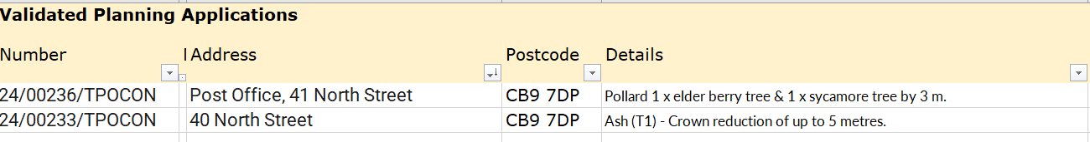
24/00246/HH – Churchfields, extension -no objection

Decisions:
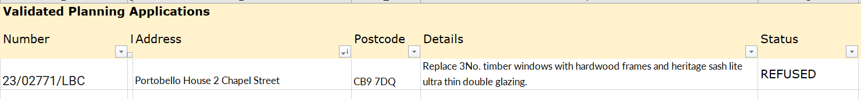

24/022 Neighbourhood plan – now ready to go to regulation 15, to put the plan to Braintree DC to do statutory consultations.
24/023 Financial Matters To note and Decision Item 1. To note receipts and approve upcoming payments. Cllr Swaby proposed to accept the report, Cllr Hexter seconded, all voted in agreement. Resolved.
Item 2. Clerk’s report - shared.
24/024 Parish Online – briefing and request for working groups to commence data upload.
This is a web-based platform which enables us to map and update almost everything in the village – it will be a fantastic resource but we all need to buy in to it. Primary goals are to get the trees on parish online – numbered as per the tree survey but with A, B or C as a prefix according to which location they are. Then assets like the benches, bins, fido bins and bus stops, finally, all the play equipment – including regular risk assessments.
Parish Online is handy because you can take a photo on geo locate and it pops it on the map for you.
Invoices and reports can be attached to each record. Working Groups are going to start with their areas.
Clerk to resend log-ins, Cllr Swaby will start with the trees and Cllr Mackenzie with Play equipment.
24/025 Open Spaces
Item 1. - Environment Agency / brook update. – the environment agency has been and removed some of the trees. There is more to do, but a great improvement.
Item 2. - Open Spaces, Trees and Assets – mapping on Parish Online was discussed earlier, the PC considered adding number tags to the trees and decided not to do this.
Cllr Rust proposed that 3 further items at the cemetery are done; stump removal, seeding and rotavating. Expected cost is approx. £1200 – Cllr Westrope seconded, all voted in agreement and it was RESOLVED. Cllr Rust and the Clerk will liaise and appoint contractors for the works.
Item 3. – Flood Initiatives Group (FIG) – Cllr Hexter has drafted a Terms of Reference for FIG, the initial expectation is that there will be a working group, including the public, which meets twice a year to tackle issues pertaining to the flooding, and maintains records which can be used to insist on actions. Once the first meeting is scheduled the clerk will write out to those who attended the January meeting.
A resident has been in touch with Cllr Mackenzie to advise Mr. Chris Gant who was recently appointed to Highways to oversee the issues about drains/floodwater phoned and he profusely apologised for the situation. The outcome is that he has arranged for a drain clearing team to clear the two blocked drains outside Lower House Farm and he will also try to attend and meet with residents to understand the specific issues with the culvert overflowing into the road which causes all the issues. He mentioned that the council might have access to what I understood to be a ‘Surface Water Alleviation Scheme’ which provides a capital grant to address issues such as the one I described.
Item 4. – Safer surface update – update with £15k allocated but quotes in excess of £20k, the two better suppliers were asked to meet with the clerk, Cllr Mackenzie and Cllr Rust to see if we could get closer to the £15k. Two new quotes of £14,850.00 & £16,538

Cllr Swaby proposes that resin bound mulch option is used plus up to £2.5k to be spent to add grass, turf seconded by Cllr Rust all in agreement. The OSWG will do some due diligence and whichever company can install prior to Easter will be asked to do the works.

Item 5. – s106 funds - The OSWG has asked for a quote to remark the basketball court and put in multi-use goal frames, plus a pétanque court and additional benches. Cllr Rust is leading on the quotes for the basketball court.
Clerk has also been in further communication with BDC and they are reluctant to seek a deed of variation, given the legal expenses. Cllr Hexter is keen to look at some gym equipment for the kids and adults and the PC considered that this should form part of a survey at the annual meeting.
24/026 Christmas Tree review – update on recent meeting & plan for 2024
In brief, overall cost was £79.20. The working group suggest that the PC agree to the same format again, but with a shorter event window of about 1.5hours, reducing the dead time at the beginning and bringing the Pizza van down to the vicarage’s driveway, keeping the public in one area.
Suggested date of 23rd November 6pm. We’d also like to write a letter to the school, Cavell choir thanking them for their contributions. A letter was sent to the bauble barn thanking them for their donation.
Vote around the table resolved stick to the 23rd November.
24/027 Information Sharing – Cllr Swaby – approached by a resident who would like to put a bench by Bellropes, Cllr Westrope – none, Cllr Hexter – planning the seed swap, then seedling swap afterwards. Cllr Rust – Cemetery looking good now. Trees down by bowls club, finger post down at the Endway has been reported.
24/028 Meeting Close & Date of Next meeting
Next meeting is 14th March. Meeting closed at 21.55

