Members of the Council are hereby summoned to attend the
STEEPLE BUMPSTEAD PARISH COUNCIL Meeting @ The Moot Hall
ON Thursday 13th November 2025 at 7.30pm for the purpose of transacting the following business.

Members of the press and public are welcome to attend.
8th November 2025
Julia Howard, Clerk to Steeple Bumpstead Parish Council

A G E N D A

25/146 Welcome and to receive apologies for absence Chairman
25/147 Declarations of Interest Information
To declare any Disclosable Pecuniary or non-Pecuniary Interest relating to items on the agenda
25/148 To approve the minutes (previously circulated) Decision
of the Parish Council meeting held on 9th October 2025.
25/149 Question Time Information
Public Participation Session with respect to items on the agenda and other matters of mutual interest. Please note: The maximum time allowed for this item is 15 minutes but may be extended at the discretion of the Chairman
25/150 Invitation to Cllr Peter Schwier, Essex County Council and Information
Cllr Diana Garrod, Braintree District Council to address the meeting on matters of mutual interest.
25/151 Financial Matters To note and Decision
Item 1. To note receipts and approve upcoming payments
Item 2. Budget status
Item 3. Cllr training online in new year £315 pp
Item 4. IT Update (.gov emails, MS365 and website) to meet updated SAPP requirements for audit.
25/152 Planning
Applications –
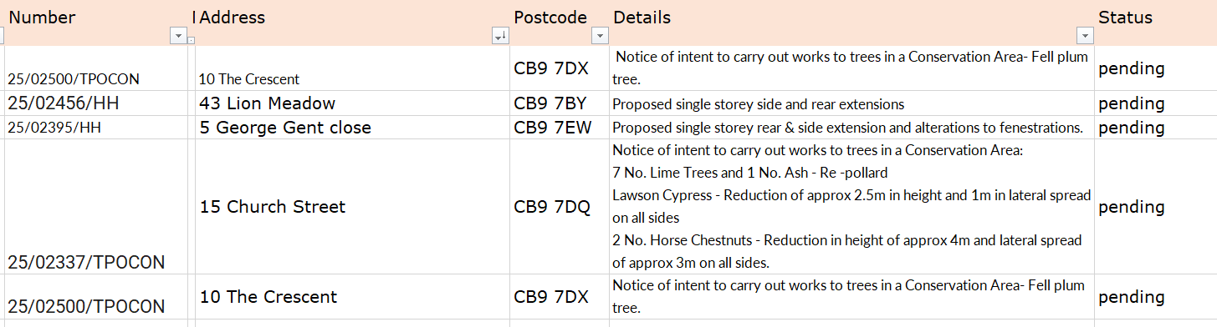

Decisions
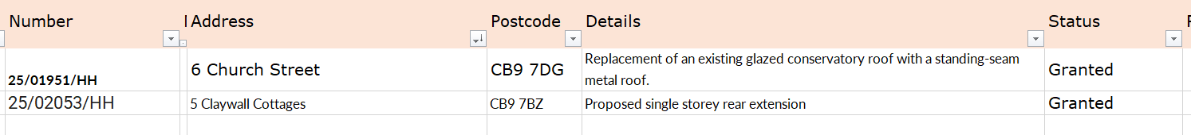
25/153 Seniors slipper exchange -17th December 10am-12noon Information
25/154 Actions from Working Groups meeting Decision
25/155 Churchyard Wall working group update Decision

O T H E R I T E M S F O R D I S C U S S I O N
25/156 Events – Christmas Planning and Remembrance Day
25/157 Yellow Book Deadline 14th November – Cllr Lacey
25/158 Update on outstanding actions from previous meeting/s
25/159 Information Sharing
25/160 Meeting Close & Date of Next meeting – 11th December.

