Members of the Council are hereby summoned to attend the
STEEPLE BUMPSTEAD PARISH COUNCIL Meeting @ The Moot Hall
ON Thursday 9th October 2025 at 7.30pm for the purpose of transacting the following business.
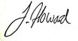
Members of the press and public are welcome to attend.
4th October 2025
Julia Howard, Clerk to Steeple Bumpstead Parish Council

A G E N D A

25/131 Welcome and to receive apologies for absence Chairman
25/132 Declarations of Interest Information
To declare any Disclosable Pecuniary or non-Pecuniary Interest relating to items on the agenda
25/133 To approve the minutes (previously circulated) Decision
of the Parish Council meeting held on 11th September 2025.
25/134 Question Time Information
Public Participation Session with respect to items on the agenda and other matters of mutual interest. Please note: The maximum time allowed for this item is 15 minutes but may be extended at the discretion of the Chairman
25/135 Invitation to Cllr Peter Schwier, Essex County Council and Information
Cllr Diana Garrod, Braintree District Council to address the meeting on matters of mutual interest.
25/136 Bus services Consultation – removal of 320/321, consultation closes on 27/10 Information
25/137 FIDO BAGS – follow up from last meeting
25/137 Financial Matters To note and Decision
Item 1. To note receipts and approve upcoming payments
Item 2. Audit update
Item 3. IT Update (.gov emails, MS365 and website) to meet updated SAPP requirements for audit.

25/138 Planning
Applications –
Decisions
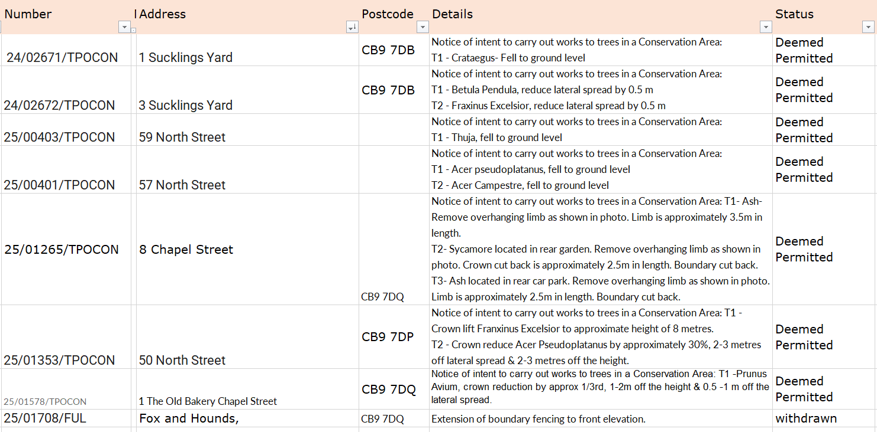

25/139 Abandoned Heras fencing at Poppyfields
25/140 Actions from Working Groups Decision
25/141 Churchyard Wall working group update Decision

O T H E R I T E M S F O R D I S C U S S I O N
25/142 Events – Christmas Planning and Remembrance Day
25/143 Update on outstanding actions from previous meeting/s
25/144 Information Sharing
25/145 Meeting Close & Date of Next meeting – 13th November.

