**STEEPLE BUMPSTEAD PARISH COUNCIL Meeting @ The Moot Hall**

**ON Thursday 10th July 2025 at 7.30pm**

Chair: Cllr Hill

Present: Cllr Westrope, Cllr Swaby, Cllr Rust, Cllr Lacey, Cllr Garrod & Cllr Schwier.

Clerk: Mrs Julia Howard

Members of the Public: one

**Draft MINUTES**

**25/093 Welcome and to receive apologies for absence** received from Chair Cllr Barnes, Cllr Mackenzie and Cllr Borges

**25/094 Declarations of Interest -** none

**25/096 To approve the minutes** (previously circulated) of the Parish Council meeting held on 12th June 2025.

RESOLVED Cllr Lacey proposed to accept these, Cllr Rust seconded all agreed by show of hands

**25/097 Councillor Vacancy** – the expiry of the BDC notice is 15th July. Then it will revert to the PC to advertise and fill the vacancy.

**25/098 Question Time** - none

**25/099 Invitation to Cllr Peter Schwier, Essex County Council and Cllr Diana Garrod, Braintree District**

**Council** to address the meeting on matters of mutual interest.

Cllr Schwier gave a summary of his report focussing on Digi-Go bus service, and the increase in numbers using the

park and ride service at Chelmsford. Future improvements include a more digitised bus tracker, which will enable

better information about bus timetables. ECC is working on local government reorganisation. There were 23

recommendations in the Essex **C**aring **C**ommunities **C**ommission Care report calling for change across the county.

Cllr Garrod gave a summary of her report (which is on the PC’s website) including road closures of Water Lane,

Hempstead road on the route to Safron Walden from 23rd July for 30 days. The clerk asked whether it is possible to

have bins to allow recycling on the camping close, or other public areas and was asked to email into street scene for

information. Greater Anglia is being privatised. 10 out of 15 Councillors in Essex have voted to have 5 unitary

authorities across Essex in the Local Government Reorganisation.

The call for sites locations has progressed and are looking at larger sites, more information is available on Cllr

Garrods report and BDC planning portal, there are clear concerns over the pressures on the local infrastructure.

Rural prosperity fund is open, primarily for businesses that want to grow / expand. Braintree Police Counter services

are being removed / closed, however you can still make an appointment to see someone there.

**25/100 Appointment of Handyman –** following recent interviews **Decision**

RESOLVED The personnel working group have interviewed 2 applicants and subject to approval by full Council, an offer letter has been sent with contract and starter checklist to Mr Ben Moon, start date 14th July (Monday).

Cllr Rust proposed to support this employment, seconded by Cllr Westrope and all voted in agreement.

The working group would also like to employ the other candidate on 2 hours a week for an initial term of 3 months at £9/hr, this was agreed by the Council however by the time of writing these minutes the applicant found alternative employment and declined the offer.

**25/101 Financial Matters To note and Decision**

**Item 1.** To note receipts and approve upcoming payments,

RESOLVED Cllr Rust proposed to approve the payments and Cllr Lacey, all agreed by show of hands.

**Item 2.** Insurance update we are now insured with Zurich

**Item 3.** Audit update **–** no new update

Cllr Lacey left the meeting temporarily.

**Item 4.** IT Update (.gov emails, MS365 and website)to meet updated SAPP requirements for audit.

The task group have met and looked at some options. Cllr Swaby gave an update.

MS365 has been paid for the current year.

**25/102 Planning**

**Applications**

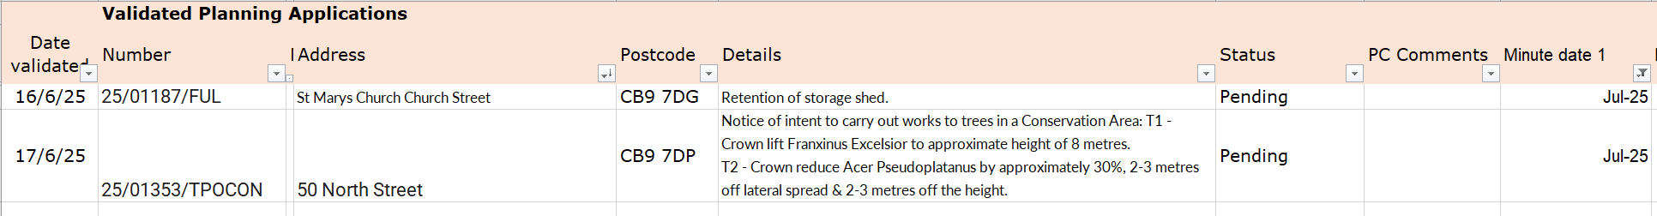

25/01187/FUL – the Planning working group recommended to **not support** this application as it is not in

keeping with the grade I listed building.

25/01353/TPOCON – The PC supports this application for tree management.

**Decisions**

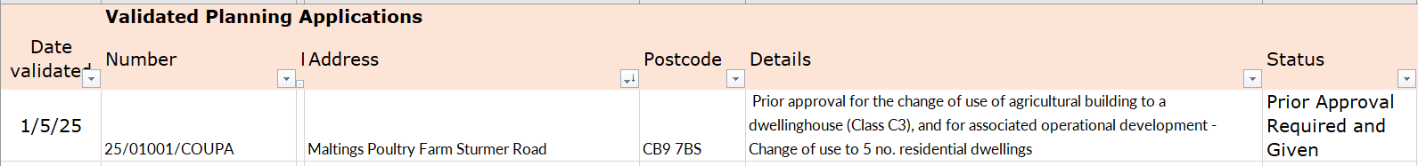

**Other – None at present.**

**25/103 Official Opening of the new equipment at the Camping Close** – 13th July **Information**

Cllr Rust and Cllr Mackenzie are meeting with Caloo to undertake snagging and sign off. On Sunday there will be an official opening and picnic from 11am-2pm. Please share the FB post and event. The Haverhill ice cream van is booked, Portobello will be on site, the PC will sell soft drinks (cans) to raise funds (Cllr Rust is arranging this). The clerk has ordered equipment for games, which can be used for future events. Cllr Lacey is arranging beat the goalie with prizes, sponsored by Steeple Stores.

**BDC** will be there at around 10.30 for a photo for some publicity as it was a s106 grant. *Anyone in the photo needs to sign the photo consent form for GDPR purposes – they can do this easily online prior to the event here:*[*www.braintree.gov.uk/photoconsent*](http://www.braintree.gov.uk/photoconsent)*.*

**25/104 Actions from Working Groups meeting Decision**

The working group meeting was useful and there are some actions which have been circulated (see 10 actions in document). It was suggested to have another one in around 6 months – perhaps November time.

Following the recent tragic events at Chalkwell park, the PC queried when our next tree survey is due and it is due in 2026 (every 3 years), the clerk will look to book it in for April 26 and ensure it is in the budget for 2026-7

In*Bloom* needs a new lead, it may be the new councillor once recruited, in the meantime the clerk has planted up 2 of the pots and Debbie Hartshorn is doing some more. Cllr Rust and Cllr Mackenzie will be the primary liaison for the Handyman and for Zion for the time being.

Recommended repairs to the play equipment as follows as per ROSPA requirements:

1. To supply new posts and metal post feet and replace 6 posts on climbing frame £2695 + VAT
2. To provide and replace rope net on climbing frame £1025 + VAT
3. To shorten swing chains £150 + VAT (this would be halved if you decided to put in a basket swing, which could not go on existing posts)

RESOLVED Cllr Lacey proposed to agree the spend, Cllr Swaby seconded and all voted by show of hands. Total cost: £3870 +VAT to be paid from the budget line ‘Asset maintenance and repair’ which has £5222 at present.

RESOLVED Cllr Rust proposed purchase as below, Cllr Westrope seconded and all agreed by show of hands.. Recommend purchase of metal signage for the camping close – also some signage for zip wire (initially a laminated version will be put up). Additional signage may be needed.

1. 1xA1 sign @ £64 + VAT
2. 3 xA3 signs @ £66 +VAT

**25/105 Churchyard Wall working group update Decision**

The working group has received quotes for structural engineering quotes to create a priority report. Quote 1. Hugh Levy £825, Quote 2. AFP £850+VAT, the working group recommends AFP. Cllr Swaby will have more details and the actual quotes.

RESOLVED Proposed by Cllr Swaby to appoint AFP, Cllr Rust seconded all agreed by show of hands.

**O T H E R I T E M S F O R D I S C U S S I O N**

**25/106 Events – VJ day, 15th August –** the poppies & silent soldiers are going up as per VE day

**25/107 Yellow Book deadline – 18th July.** Cllr Hill will be drafting it and sending to the Clerk

**25/108 Update on outstanding actions from previous meeting/s**

1. Donation of bench – Chair Cllr Barnes is liaising with a member of the public 2. Storage of the winter salt – Cllr Rust is arranging this in the coming weeks with a removable / slab base beside the players shed – alternatively it can go by the fence in the plantation 3. Noticeboard removal / installation, delayed, Cllr Swaby will do this. In the meantime, the doors and drawing pins are to be removed from old notice board for safety reasons. 4. Gate at churchyard – waiting for a tree to be cut back first, requires a faculty for this

**25/109 Information Sharing –** Cllr Westrope – none, Cllr Swaby – None, Cllr Lacey – none, Cllr Rust – made the PC aware of a political booking on 23rd August and a request to use the camping close for carparking in return for a donation, the Chair and clerk have agreed with this. The PC is a-political and the booking has no bearing on this.

**25/110 Meeting Close & Date of Next meeting –** meeting closed at 9.15.The next meeting is 11th September.

