District Councillor's Report to Parish Councils March 2024
Cllr. Diana Garrod - Bumpstead Ward

Scheduled Temporary Traffic Regulation Orders & Roadworks
Intended closure of Wiggens Green, Helions Bumpstead on 3rd May 2024 for one day. The closure is required whilst Openreach undertakes pole testing. https://one.network/?tm=137394156

Intended closure of Haverhill Road, Helions Bumpstead due to commence on 25th March 2024 for 12 days. The closure is required while Essex County Council undertakes sewer connection. https://one.network/?tm=137010158

Braintree District Council sets budget of £19.6 million for 2024-25
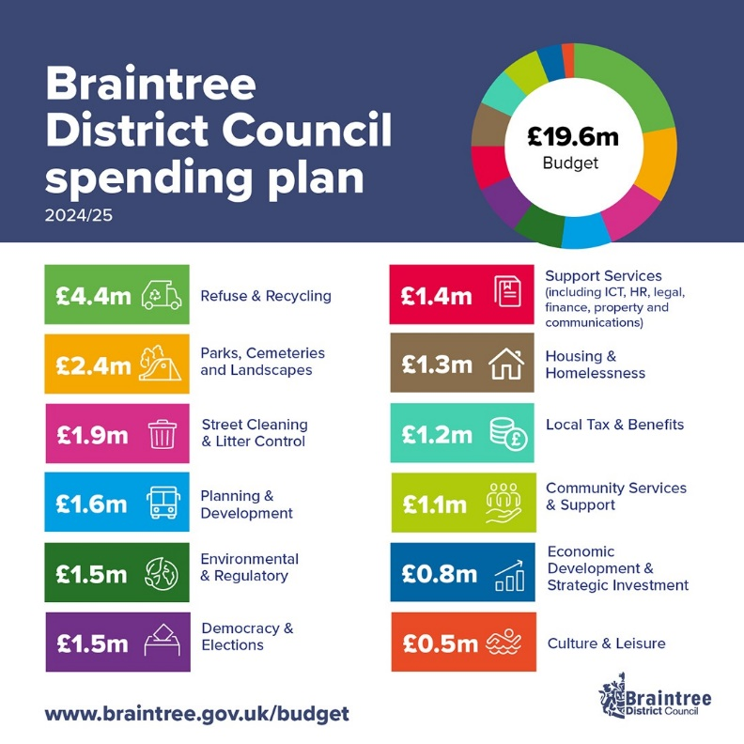
Prudent financial management means Braintree District Council is in a sound position this year compared to many other councils, despite ongoing financial pressures driven by inflation, increased demand on services and uncertainty over long-term government funding. Whilst the council has prudently set aside reserves as part of its long-term financial planning, a budget deficit increasing up to £2.3m per year is predicted up to 2027-28.

With 60% of the council’s net budget being funded from council tax, this will increase by an extra 11p per week based on a Band D property to help protect services, ensure that unavoidable cost pressures can be met and to support longer-term financial stability (2.96%). Braintree District Council continues to remain one of the lowest council tax rates in Essex and below the national average of shire districts.

How the budget is funded
BDC’s total budget is £19.6 million for 2024-2025.
Some of the priorities delivered 2022/23

This is funded by:

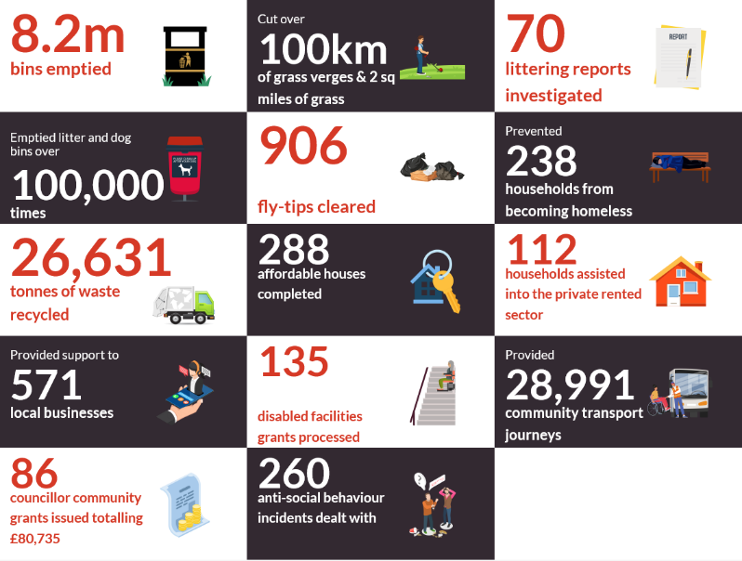
- 60% council taxpayers
- 35% business ratepayers
- 5% central government grants

Although BDC collects council tax, the money doesn't just pay for our services. It also pays for services by the police, fire, county council, parish and town councils too. For every £1 people pay in council tax, just over 9p goes to Braintree District Council. Essex County Council receives 72p, Essex Police & Crime Commissioner receives 12p, Essex Fire Authority receives 4p and parish and town councils receive 3p.

Wethersfield – Prison Proposals
By way of an update: Councillor Graham Butland, Leader of Braintree District Council, made the following statement in late January: “The Ministry of Justice (MoJ) have engaged with us as part of pre-application advice on their prison proposals, something any developer can request, however we have not received a formal planning application from them yet. If and when the Council receives a planning application, potential impacts on the local community will be explored in full and residents, partners and businesses will have the opportunity to submit their views and comments through the planning process. We will keep residents updated if and when we learn more about the next stage of the process from the MoJ.”

Any further information will be put on the web page as and when it arises:

https://www.braintree.gov.uk/news/article/380/braintree-district-council-sets-out-its-position-over-wethersfield-prison-proposals

Wethersfield – Airfield Asylum Accommodation Centre
BDC has a dedicated section on their website to keep you updated on the Home Office’s asylum accommodation centre at Wethersfield Airfield. A factsheet relating to Wethersfield Asylum Accommodation and a community newsletter at Gov.Uk which they have advised will be regularly updated with the latest information and updates.

https://www.gov.uk/government/publications/asylum-accommodation-wethersfield

Lean2Green offers free carbon-cutting support to Braintree District businesses
Braintree District Council is encouraging small businesses in the district to take up an opportunity to secure free expert advice and support on working more sustainably. Essex County Council has contracted Tiptree-based MKR Consulting Ltd to provide first come, first served one-to-one sessions to 20 Small and Medium Enterprises in the Braintree and Uttlesford districts. The project will support the delivery of the District’s Climate Change Action Plan 2023/24, encouraging businesses to build resilience and to develop the green economy. MKR Consulting Ltd’s own Lean2Green approach aims to get businesses on the road to net zero without a large financial outlay, through efficiencies and clear action plans. They provide follow up calls at three and six month intervals, giving the support for businesses to remain on track. To qualify, businesses must be based in the Braintree or Uttlesford district, have been operating for at least 18 months and have three or more employees. Initial applications must be made directly to MKR Solutions Ltd, who will then advise businesses whether they have been successful.

Applications can be made here: https://calendly.com/mkrsolutionsltd/general-discovery-call

Braintree District Council take action on illegal advertising
Braintree District Council was successful in prosecuting an individual for unauthorised advertising in a lay-by, resulting in fines and costs totalling over £3,000. Anthony Devito was convicted for unlawfully using a vehicle for advertising purposes between 8 February and 4 May 2023, where a vehicle displaying a logo for his business was left in a lay-by on the A12 for the sole purposes of advertising. Despite the individual receiving advice from the council’s enforcement team about needing advertising consent under the national planning system, Mr Devito returned the vehicle to the A12 at a later time. He received a criminal conviction for both offences at Colchester Magistrates Court on Thursday 8th February 2024 and was ordered to pay fines and costs totalling £3050.58.

Homelessness & Rough Sleeping Strategy: Consultation ends 1st April 2024
BDC would like to know what priorities to tackle homelessness and rough sleeping are most important to you. Anything you tell the Council is useful so please answer as many questions as you like, in as much or as little detail as you like. You do not have to answer every question. Your feedback will be used to inform the final version of the strategy which is set to be approved in May 2024.

Details at:
https://www.braintree.gov.uk/housing/homelessness-rough-sleeping-strategy-2024-%E2%80%93-2029?utm_medium=email&utm_source=govdelivery

Cllr. Diana Garrod
Braintree District Councillor - Bumpstead Ward

