Advent window – rules

1. Register for a number (provide your name & address) (the Clerk will allocate an advent number to you; you can suggest a preference) [clerk@steeplebumpstead-pc.org](mailto:clerk@steeplebumpstead-pc.org)
2. Your property must be in Steeple Bumpstead, and accessible for viewing
3. Create a ‘polite’ display in any visible window in your property, suitable for all to view and enjoy
4. Make sure your advent number is on display in the window
5. Unveil the window display on your designated date and keep it unveiled until Christmas Day
6. Enjoy it and have fun sharing the Christmas Spirit

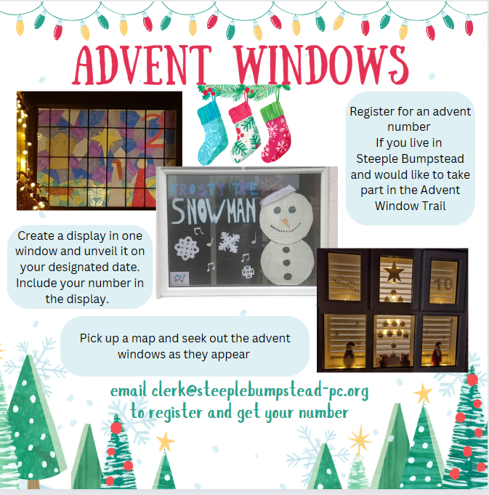

Note:

By registering you are giving permission for photos of your property and window to be shared. You are agreeing to have your address detailed on a map of Advent windows

There are no charges for taking part and no costs will be met by the Parish Council.

Maps will be available at the Big Switch on and online.