STEEPLE BUMPSTEAD PARISH COUNCIL Meeting @ The Moot Hall ON Thursday 13th November 2025 at 7.30pm

Chair: Cllr Kerry Barnes
Present: Cllr Aldred, Cllr Mackenzie, Cllr Westrope, Cllr Hill, Cllr Borges, Cllr Rust, Cllr Swaby, Cllr Garrod
Clerk: Mrs Julia Howard
Members of the public: none

Draft Minutes

25/146 Welcome and to receive apologies for absence from Cllr Lacey and Cllr Schwier
25/147 Declarations of Interest - none Information
To declare any Disclosable Pecuniary or non-Pecuniary Interest relating to items on the agenda
25/148 To approve the minutes (previously circulated) of the Parish Council meeting held on 9th October ‘25
RESOLVED by show of hands.
25/149 Question Time - none
25/150 Invitation to Cllr Peter Schwier, Essex County Council and Cllr Diana Garrod, Braintree District Council to address the meeting on matters of mutual interest.
Cllr Garrod gave a summary of her report, which is on the PC’s website. The outcome of the public transport
consultation is due to be published next month. There are several grants available. ECC User Highway survey is
live and residents can have their say.
25/151 Financial Matters To note and Decision
Item 1. To note receipts and approve upcoming payments as circulated.
RESOLVED Proposed by Cllr Hill, seconded Cllr Aldred, all in agreement by show of hands.
RESOLVED Following on from previous month’s agenda items we have a price for the speed survey for the Quiet Lane, the speed/traffic measure survey would be £368.20 – it was proposed by Cllr Mackenzie to agree to this spend seconded by Cllr Borges, all in agreement by show of hands.
Item 2. Budget status – as circulated, this is for information, Cllr’s are asked to contact the clerk for any additional expenditure queries.
Item 3. Cllr training online in new year £315 pp – Cllr Aldred has asked to do this, however the Chair
would prefer to have EALC deliver the training to the full PC, Cllr Aldred will contact EALC to determine costs and dates for the training and report back.
Item 4. IT Update (.gov emails, MS365 and website) to meet updated SAPP requirements for audit.
A draft of the new website was circulated (some content is old/out of date) once agreed the domain name will be applied for. The clerk asked Cllrs to comment by email no later than Wednesday if they had any comments on the website.
25/152 Planning
Applications –
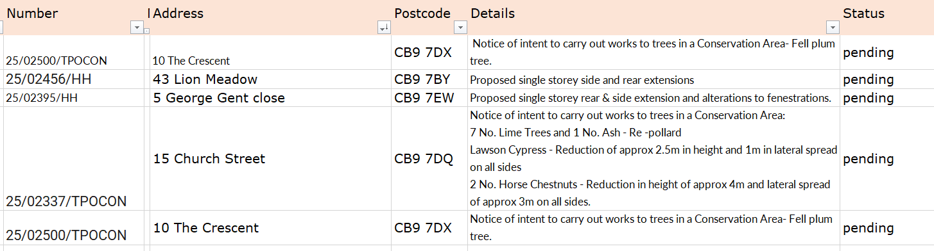
- TPO – no comment, 2. No objection, 3. No objection, 4. TPO – no comment

Decisions
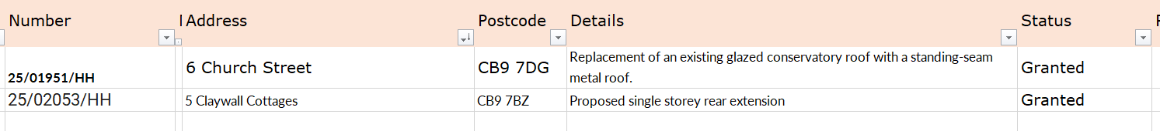
25/153 Seniors slipper exchange -17th December 10am-12noon Information
25/154 Actions from Working Groups meeting Decision
Zip Wire update, 1 household has made a complaint of the noise of children / adults using the zip wire. The OSWG has been tasked with investigating and undertaking the following tasks and will feedback in due course.
1. observe the issue at the times suggested by complainant.
2. enquire with neighbouring parishes regarding any issues with their zip wires
3. Purchase signage and install at the zip wire
4. enquire with ROSPA about a noise survey
5. obtain a quote for moving the zip wire to the other side of the basketball court/MUGA

Purchase of new grit bin for The Endway – Cllr Mackenzie and Cllr Rust to determine size and location and to speak to Steeple Stores about a further grit bin being placed on their forecourt and bring back to PC meeting for decision.
25/155 Churchyard Wall working group update - clerk to instruct AFP at cost of £850+VAT
RESOLVED Proposed by Cllr Rust seconded by Cllr Westrope. All agreed. To be spent from earmarked account.

O T H E R I T E M S F O R D I S C U S S I O N
25/156 Events – Christmas Planning and Remembrance Day
Remembrance Day was well attended and the poppy displays looked great.
Christmas planning – the working group met recently and gave a brief update. The event starts at 6pm and the switch on is 7.30pm. Stewards are needed. Scouts will also be involved helping out on the evening. Banners will be going up again.
Advent windows – we still have lots of spaces, email the clerk if you’d like to get on the map.
CAVRA Christmas tree recycling is available – book your own collection, from 7th -12th January
25/157 Yellow Book Deadline 14th November – Cllr Lacey to do draft. We are looking for a volunteer to do lead the guided walk, please contact Cllr Rust if you can help with this.
25/158 Update on outstanding actions from previous meeting/s
1. Donation of bench – in progress, awaiting a date to install 2. Storage of the winter salt – will be done when the bench goes in, 3. Damaged paving slabs by new notice board to be replaced / re-laid at the same time as 1&2. 4. Gate at churchyard – waiting for a tree to be cut back first, requires a faculty for this
25/159 Information Sharing – request for parking on camping close 15/8 awaiting fixture dates from the Football teams
Cllr Aldred – none, Cllr Mackenzie – none, Cllr Westrope – speeding vehicles at Smiths Green, Cllr Hill – none Cllr Swaby – none, Cllr Borges – none, Cllr Rust – has another request to use additional parking on 2nd January, the camping close will probably be too wet.
25/160 Meeting Close & Date of Next meeting – 11th December.

Signed by Chairman ……………………

Date …………………………………………….

