STEEPLE BUMPSTEAD PARISH COUNCIL Meeting @ The Moot Hall Thursday 11th September 2025

Chair: Cllr Barnes
Present: Cllr Westrope, Cllr Hill, Cllr Mackenzie, Cllr Lacey, Cllr Rust, Cllr Aldred
Also in attendance: Cllr Garrod
Clerk: Mrs Julia Howard
Members of the Public: Five
Minutes

25/111 Welcome and to receive apologies for absence - apologies received from Cllr Borges and Cllr Swaby
25/112 Declarations of Interest - none Information
To declare any Disclosable Pecuniary or non-Pecuniary Interest relating to items on the agenda
25/113 To approve the minutes (previously circulated) Decision
of the Parish Council meeting held on 10th July 2025.
RESOLVED proposed as a true record by Cllr Lacey, seconded by Cllr Rust and all agreed by show of hands
25/114 Co-Option of new Councillor following recent interviews Information
RESOLVED Four candidates were interviewed and were all excellent, the recommendation from the Personnel working group is to co-opt Ann Aldred. Proposal put forward by Cllr Barnes, seconded by Cllr Hill all in agreement by show of hands
25/115 Question Time Information
- The first member of the public to speak raised concerns about the location of the zip wire and proximity to housing and the noise of children playing. 2. Re: the bus consultation thinks it will be a disaster if the 320/321 bus services are removed. If it isn’t profitable as it is, could a smaller bus be used 3. Enquired about the possibility of a mobile post office, the Parish Council have been making enquiries and would like to see this in place.
25/116 Invitation to Cllr Peter Schwier, Essex County Council and Cllr Diana Garrod, Braintree District Council to address the meeting on matters of mutual interest.
Cllr Garrod gave a summary of her report, which is on the PC website. There are several road closures which will
affect the village, including Blois Road 28-30th October.
Essex police are now using ‘drone patrols’. The BDC local plan review is being looked at and needs to include a lot
more housing (8000+), incl. potentially 3000 properties on the edge of Sturmer / Culina area. The West Suffolk
exclusion plan is on their website which identifies some of the reasons it had been excluded in the past.
Local government reorganisation was discussed. There is a proposal to remove the 320/321 bus services leaving only
the 319. Visit: https://consultations.essex.gov.uk/iptu/localbus2025 to complete the consultation. It is open now
until 27 October 2025.
The ECC bus consultation closes on 24th September and is on the PC’s website. Chair Barnes asked about the
Wethersfield site and a discussion ensued; Cllr Garrod has requested an update on this.
Cllr Schwier gave his summary at 20.26, highlighting the transport consultation. He also gave the pothole stats in Jan
23 there were 5000 pot holes reported, in Jan 2024, 4000 were reported and in January 2025 only 1600 were
reported. The situation is improving and making our roads safer. Winter cutting reminder, land owners, farm
owners, public areas, please cut back your hedges, trees, vegetation to ensure signage is visible and footways are
accessible.
25/117 Changes to Bus services – the proposal is to remove the 320/321, leaving the 319 which doesn’t go through Steeple Bumpstead. The village now has no GP, no post office and limited services in the village, therefore more people need to use the busses / public transport to access services.
Cllr Schwier arrived at 20.15 and was able to speak on this item. He suggested formulating the primary concerns into a letter to send to Cllr Schwier to provide to the cabinet lead on this matter. Cllr Lacey and the Clerk will work together to write a response.
25/118 Traffic and Safety at Field View, off Water Lane – This was raised by a parishioner and was reported to Cllr Schwier, the community police and Highways department. It may warrant some additional signage and a look at the vegetation. Cllr Mackenzie will investigate and look at the location of the 30mph signs.

25/119 Provision of FIDO Bags / dispenser – following parishioner contact Decision
A parishioner has suggested that the Parish Council and/or businesses provide some FIDO bags and dispensers around the village. The Chair suggests that we look at the costs of dispensers and bulk purchase of the bags prior to the next month. The Chair will enquire with the clerks at BALC and the clerk will enquire with the clerk’s forum to hear whether this is a positive initiative.
25/120 Report from Handman Mr Moon -an update on recent activities Decision
The Chair suspended standing orders at 20.53 to allow Mr Moon to give an update on his handyman activities.
He has recently put some wedges under the bridge footway, and the new bridge at crescent road is beginning to twist. The boards around the play area have been assessed and would cost around £100 in timber. There are parts of the football shed that need repair / replacement.
The Chair raised the point of needing a lockable tap on the outside of the football shed for the watering of the planters, Ben will take a look at this.
Ben is happy to work with Councillors to get the new notice board installed.
On the riverside footpath there is a steep bank, which is a bit dangerous and may need to put some wooden supports / railings up, there are hedges overgrowing on the other side. This is a permitted footpath, maintained by BDC. Cllr Mackenzie and Cllr Lacey will have a look and see what can be done and report back to the PC by email.
Standing orders were resumed at 21.12 and following the delivered report Cllr Lacey proposed that £150 spend is agreed to, in order to purchase the timber to repair the play area and any other required materials. This was seconded by Cllr Rust and all agreed by show of hands.
RESOLVED.
25/121 Financial Matters To note and Decision
Item 1. To note receipts and approve upcoming payments
RESOLVED Cllr Rust proposed to approve the payments, Cllr Westrope seconded and all agreed to approve the payments.
Item 2. Audit update – the internal audit report was queried and amended by the Internal auditor.
Item 3. IT Update (.gov emails, MS365 and website) to meet updated SAPP requirements for audit.
RESOLVED The Chair and Clerk have looked at Parish Council Websites as a provider and it will cost around £700
It was proposed by Cllr Rust that the clerk and Finance group will make a decision on the supplier and move this forward, seconded by Cllr Hill and all in agreement by show of hands.
RESOLVED MS365 can be purchased through SARALA at £11.52+ VAT /mth. This was also approved, by show of hands.
The current website and emails will be extended for 1 further year to allow for the transition.

25/122 Planning
Applications
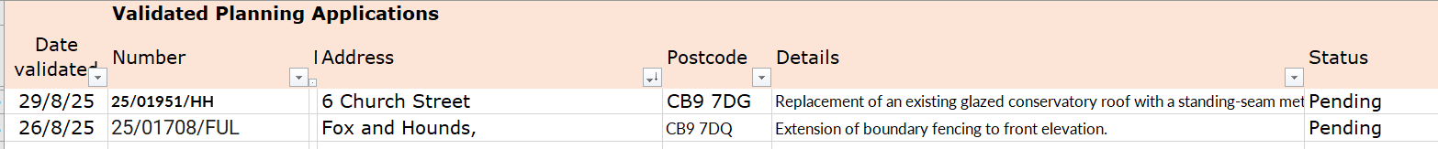
6 Church street – no comment
Fox and Hounds – no objection

Decisions
Other – None at present.

25/123 Actions from Working Groups meeting Decision
Play area repairs are due to be done by Mortimer, who have contacted and will get them done ASAP.
RESOLVED We have a quote of £140 from Treeworx to remove the tree at the back of the school which is leaning badly – all were in agreement of this spend by show of hands
It was confirmed that 6 metal signs are required for Camping close, the clerk will order these.
The footpath alongside the school is overgrown with brambles and weeds growing up through broken path,
Cllr Rust and Cllr Mackenzie will take a look. Zion has attended twice and cleared this.

25/124 Churchyard Wall working group update Decision
This item is currently with Cllr Swaby for the next steps. Chair Barnes will follow this up with Cllr Swaby
O T H E R I T E M S F O R D I S C U S S I O N
25/125 Events – Christmas Planning and Remembrance Day – The Christmas tree lighting will be held on Saturday 29th November 6-7.30pm (this is a change to the original date due to a clash), there will be singing, food, ice-cream etc at the village hall. A live feed of the Christmas tree to the village hall would be great, so the working group will investigate the practicality of this. Members of the public are welcome to get involved, please contact Cllr Lacey for meeting dates.
The Remembrance Day service will go ahead as usual on 9th November, the war memorial will be cleaned in preparation and the graves in the cemetery too, Cllr Westrope will lead the preparations. More donations of knitted / crocheted poppies are still wanted to enhance our display, we are looking to add a poppy back drop at the war memorial – poppies can be handed to any member of the Council or into the library or contact the Parish Clerk.
25/126 Yellow Book deadline – Friday 13th September, Cllr Mackenzie is doing this editions report and will send to the clerk. Cllr Lacey will do the November draft.
25/127 Update on outstanding actions from previous meeting/s
No further progress on these at the moment. Please refer to July minutes.
25/128 Advertising within the village – a member of the public has reported some advertising around the village and asked to put their own up.
There are rules around putting up signage and advertising and there are substantial fines if you do not have the correct permissions and fly post. Please contact Chair Barnes if you’d like to know more.
25/129 Information Sharing – ‘sloppy slipper exchange’ to be held in the Village Hall date tbc in approx. December this year – bring your old slippers and get new ones and reduce the risk of falls and stumbles, Cllr Westrope – the brook is overgrown again, Cllr Hill – none, Cllr Mackenzie – there is a pallet in the brook by the Endway, Cllr Lacey – none, Cllr Aldred – the village gardening club was formed and has a program of activities for the next 3 months, enquiry about a community allotment, Cllr Rust – footpath 29, resident will be submitting an application to extinguish footpath going through their property, there have been 2 very large events at the VH and used the CC for car parking and has worked very well, 2 more are booked this year.
25/130 Meeting Close & Date of Next meeting – 9th October. Meeting closed at 22.10

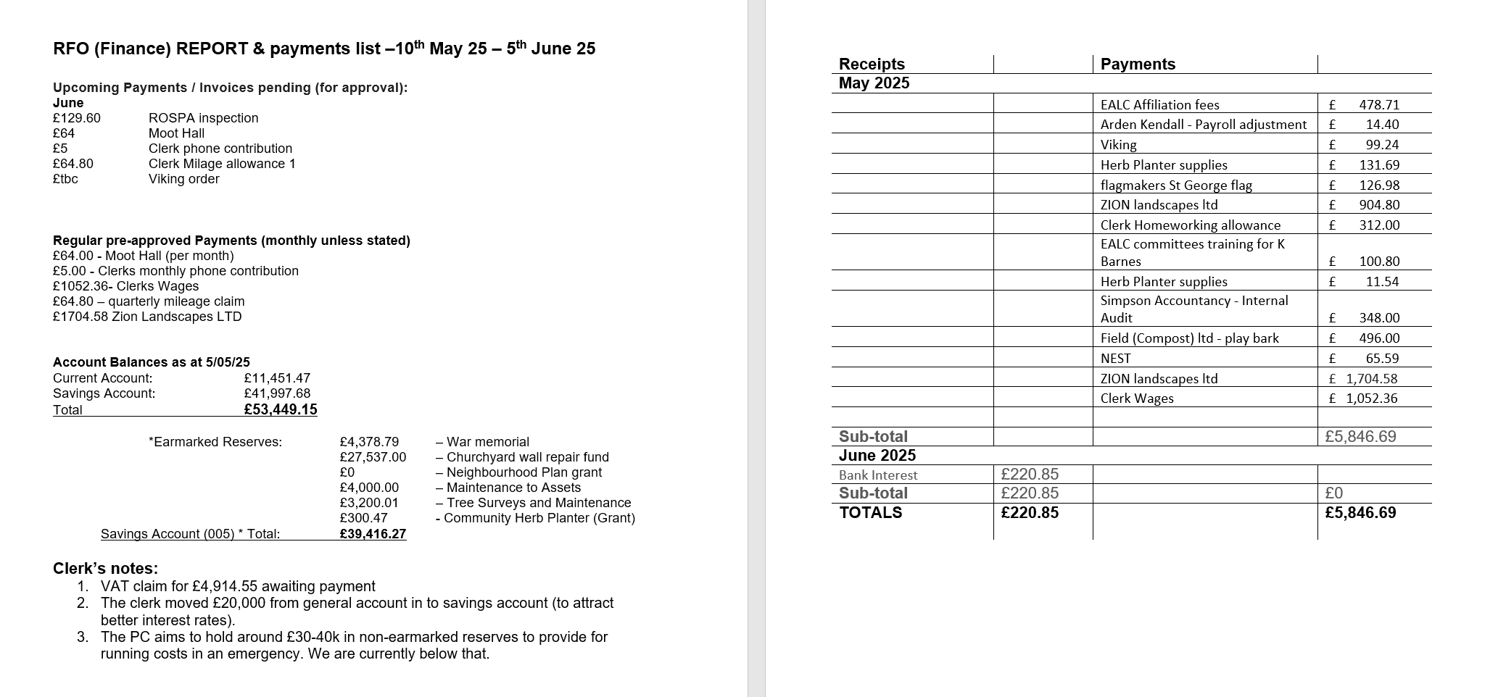
Signed by Chairman ……………………

Date …………………………………………….

